|  |
| --- |
| BSc (Hons) Computing and Systems Development |
| 4SB Technical Documentation |
| Unit CSD301 |

|  |
| --- |
| Amy Falconer  Student ID: 126185 |

Contents

2. Design Method Tools & Techniques 2

2.1 Mobile Application 2

2.2 Database Design 2

3. Functional Requirements 3

3.1 Functional Requirements 3

3.2 Context of the work 9

3.3 Data Model 11

3.4 Data Dictionary 11

3.5 ERD 32

3.6 Entity Relationship Matrix 40

3.7 Product Boundary 41

3.8 Product Use Case Table 41

4. Non-Functional Requirements 42

4.1 Appearance and style requirements 42

4.2 Wireframing 43

4.3 Wireflow 52

5. Code Snippets 56

6. Testing 58

1. Introduction

This document is intended to provide the data needed to continue support for the 4SB android application. Included will be the design documentation for the app and database as well as the functional and non-functional requirements of the product. Testing conducted on the prototype is included.

# 2. Design Method Tools & Techniques

## 2.1 Mobile Application

The android application design process included the following techniques:

* Mood board
* Wireframing
* Wireflow

## 2.2 Database Design

The database contains 41 tables and the design process included the following techniques:

* Use Case Scenarios
* User view normalisation
* Link phrase checks
* ERD
* DFD
* Data Dictionaries

# 3. Functional Requirements

## 3.1 Functional Requirements

**Requirement:** 001 **Requirement Type:** Functional **Event/use case:** 2

**Description:** The system must create a customer record within the database, generating a unique customer_id and containing a valid email address, when a customer enters an email address into the form on the app.

**Rational:** This record allows the customer to access the app.

**Originator:** Miss Amy Falconer.

**Fit criterion:** The customer must be able to unsubscribe through the confirmation email and the application as well as and being informed of an error when subscribing to the app if necessary. Permissions must be granted by the user for the app to access phone storage and features.

**Customer satisfaction:** 5 **Customer dissatisfaction**: 1

**Priority:** A rating of admin’s and **Conflicts:** None

subscriber’s satisfaction.

**Supporting materials**: BUC #2, PUC#2.1 & 2.2

**Volere**

**History:** created 20/04/2019 Copyright © Atlantic Systems Guild

**Requirement:** 002 **Requirement Type:** Functional **Event/use case:** 3

**Description:** The customer inputs required guest amount, time and date into form and queries the database. System returns available tables and details. Customer chooses table and confirms reservation. Confirmation email is sent to customer and admin is notified.

**Rational:** This record details the customer’s table reservation.

**Originator:** Miss Amy Falconer.

**Fit criterion:** The customer must be able to cancel or update the reservation record up to 2hr prior to reservation. Record contents validated on submission. If any errors, customer is notified, and error record is entered in the error log.

**Customer satisfaction:** 5 **Customer dissatisfaction**: 1

**Priority:** A rating of admin’s and **Conflicts:** None

subscriber’s satisfaction.

**Supporting materials**: BUC #3, PUC#3.1 / #3.2

**Volere**

**History:** created 20/04/2019 Copyright © Atlantic Systems Guild

**Requirement:** 003 **Requirement Type:** Functional **Event/use case:** 4

**Description:** The customer selects items and quantity from the menu list provided on the application, which is saved within the basket. Customer submits order, completes payment and creates an order record within the database and notifies the admin.

**Rational:** This record details the customer order.

**Originator:** Miss Amy Falconer.

**Fit criterion:** The customer must be able to add and remove items from the basket. Order and delivery times must be verified and suitable. Record contents validated on submission. If any errors, customer is notified, and error record is entered into the error log.

**Customer satisfaction:** 5 **Customer dissatisfaction**: 1

**Priority:** A rating of admin’s and **Conflicts:** None

subscriber’s satisfaction.

**Supporting materials**: BUC #4, PUC#4.1 / #4.2 / #4.3, Individual Product User Case and product boundary.

**Volere**

**History:** created 20/04/2019 Copyright © Atlantic Systems Guild

**Requirement:** 004 **Requirement Type:** Functional **Event/use case:** 5

**Description:** The customer selects items and quantity from the menu list provided on the application, which is saved within the basket. Customer submits order, completes payment and creates an order record within the database and notifies the admin.

**Rational:** This record details the customer order.

**Originator:** Miss Amy Falconer.

**Fit criterion:** The customer must be able to add and remove items from the basket. Order and delivery times must be verified and suitable. Record contents validated on submission. If any errors, customer is notified, and error record is entered into the error log.

**Customer satisfaction:** 5 **Customer dissatisfaction**: 1

**Priority:** A rating of admin’s and **Conflicts:** None

subscriber’s satisfaction.

**Supporting materials**: BUC #4, PUC#4.1 / #4.2 / #4.3

**Volere**

**History:** created 20/04/2019 Copyright © Atlantic Systems Guild

**Requirement:** 005 **Requirement Type:** Functional **Event/use case:** 6

**Description:** The admin queries the system to provide reports and business intelligence as well as reservation checks.

**Rational:** To provide management support.

**Originator:** Miss Amy Falconer.

**Fit criterion:** The reports will be generated upon request and/or on a daily schedule.

**Customer satisfaction:** 5 **Customer dissatisfaction**: 1

**Priority:** A rating of admin’s and **Conflicts:** None

subscriber’s satisfaction.

**Supporting materials**: BUC #5, PUC#5

**Volere**

**History:** created 20/04/2019 Copyright © Atlantic Systems Guild

**Requirement:** 006 **Requirement Type:** Functional **Event/use case:** 7

**Description:** The admin inputs a new record for either a promo or an event. Upon successful verification and save to database, the customer’s will be updated to the record through a push notification.

**Rational:** To advertise new promotions and events to customers directly.

**Originator:** Miss Amy Falconer.

**Fit criterion:** The record will be validated before saving to database. Customers whom have disabled push notifications will not receive the alert.

**Customer satisfaction:** 5 **Customer dissatisfaction**: 1

**Priority:** A rating of admin’s and **Conflicts:** None

subscriber’s satisfaction.

**Supporting materials**: BUC #9 & #10, PUC#9 & #10

**Volere**

**History:** created 20/04/2019 Copyright © Atlantic Systems Guild

**Requirement:** 007 **Requirement Type:** Functional **Event/use case:** 8

**Description:** The admin inputs a new record for either a menu, item or an employee. Upon successful verification and save to database, the admin will receive confirmation notification.

**Rational:** To update application content.

**Originator:** Miss Amy Falconer.

**Fit criterion:** The record will be validated before saving to database.

**Customer satisfaction:** 5 **Customer dissatisfaction**: 1

**Priority:** A rating of admin’s and **Conflicts:** None

subscriber’s satisfaction.

**Supporting materials**: BUC #8, #11 & #12, PUC#8, #11 & #12

**Volere**

**History:** created 20/04/2019 Copyright © Atlantic Systems Guild

## 3.2 Context of the work

The processes of the product and its workload are depicted in the following context diagram.

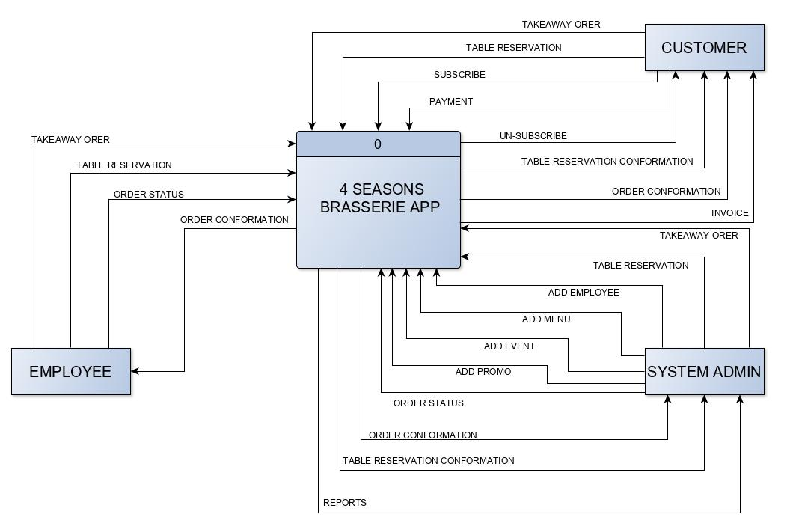

## 3.3 Data Model

The data model for the 4SB database is illustrated in the following UML data model to show cardinality and relationships between the database tables.

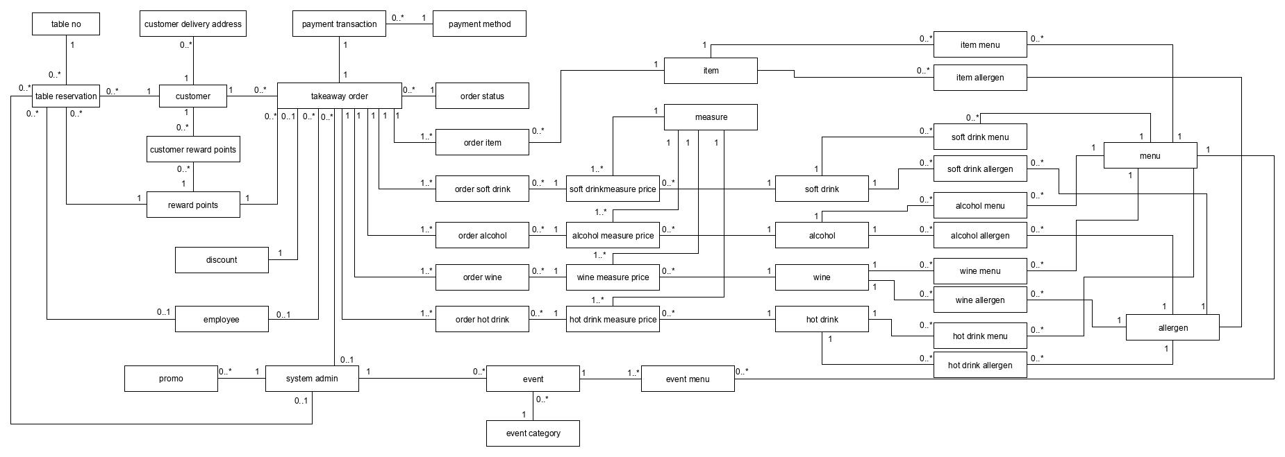

## 3.4 Data Dictionary

#### 3.4.1. System Admin Data Dictionary

|  |  |  |  |  |  |  |  |  |  |
| --- | --- | --- | --- | --- | --- | --- | --- | --- | --- |
| **Table:** | system_admin |  |  |  |  |  |  |  |  |
|  |  |  |  |  |  |  |  |  |  |
| **Field Name** | **Data Type** | **Data Format** | **Example** | **Description** | **Validation** | **Character Length** | **Null Value** | **Required?** | **Key** |
| system_admin_id | TINYINT |  | '1234' | PK for the System Admin table | n/a | 3 | NOT NULL | Y | PK |
| first_name | VARCHAR |  | 'John' | First Name for System Admin record | n/a | 20 | NOT NULL | Y |  |
| last_name | VARCHAR |  | 'Smith' | Surname for System Admin record | n/a | 20 | NOT NULL | Y |  |
| username | VARCHAR |  | 'Smith123' | Unique Username for System Admin record | n/a | 20 | NOT NULL | Y |  |
| password | VARCHAR |  | 'johnSmith123' | Hashed password for the contributor conforming to the validation rules. | Must contain at least 1 number, 1 uppercase, 1 lowercase. Minimum 8 characters | 20 | NOT NULL | Y |  |
| timestamp | TIMESTAMP | DD-MM-YYYY HH:MM:SS | '01-01-0000 00:00:00' | Time and Date record was created | n/a |  | NOT NULL | Y |  |

|  |  |  |  |  |  |  |  |  |  |
| --- | --- | --- | --- | --- | --- | --- | --- | --- | --- |
| **Table:** | employee |  |  |  |  |  |  |  |  |
|  |  |  |  |  |  |  |  |  |  |
| **Field Name** | **Data Type** | **Data Format** | **Example** | **Description** | **Validation** | **Character Length** | **Null Value** | **Required?** | **Key** |
| employee_id | TINYINT |  | '1234' | PK for the Employee table | n/a | 3 | NOT NULL | Y | PK |
| first_name | VARCHAR |  | 'John' | First Name for Employee record | n/a | 150 | NOT NULL | Y |  |
| last_name | VARCHAR |  | 'Smith' | Surname for Employee record | n/a | 200 | NOT NULL | Y |  |
| username | VARCHAR |  | 'Smith123' | Unique Username for Employee record | n/a | 150 | NOT NULL | Y |  |
| password | VARCHAR |  | 'johnSmith123' | Hashed password for the contributor conforming to the validation rules. | Must contain atleast 1 number, 1 uppercase, 1 lowercase. Minimum 8 characters | 30 | NOT NULL | Y |  |
| timestamp | TIMESTAMP | DD-MM-YYYY HH:MM:SS | '01-01-0000 00:00:00' | Time and Date record was created | n/a |  | NOT NULL | Y |  |
| system_admin_id | TINYINT |  | '1234' | PK for the System Admin table | n/a | 3 | NOT NULL | Y | FK |

|  |  |  |  |  |  |  |  |  |  |
| --- | --- | --- | --- | --- | --- | --- | --- | --- | --- |
| **Table:** | promo |  |  |  |  |  |  |  |  |
|  |  |  |  |  |  |  |  |  |  |
| **Field Name** | **Data Type** | **Data Format** | **Example** | **Description** | **Validation** | **Character Length** | **Null Value** | **Required?** | **Key** |
| promo_id | TINYINT |  | '1234' | PK for the Promo table | n/a | 5 | NOT NULL | Y | PK |
| promo_name | VARCHAR |  | 'Free bottle of wine with every table reservation' | First Name for Employee record | n/a | 250 | NOT NULL | Y |  |
| promo_description | VARCHAR |  | 'Book a table with us today and we shall place a bottle of wine on your table ready for your arrival' | Descriptive text for the promotion | n/a | 2000 | NOT NULL | Y |  |
| promo_start_date | DATETIME | DD-MM-YYYY HH:MM:SS | '01-01-0000 00:00:00' | Start date for the promotion to be live and active | n/a |  | NOT NULL | Y |  |
| promo_end_date | DATETIME | DD-MM-YYYY HH:MM:SS | '01-01-0000 00:00:00' | End date for the promotion to be deactivated |  |  | NOT NULL | Y |  |
| promo_cover_image | BLOB |  |  |  | n/a |  | NULL | N |  |
| promo_terms | VARCHAR |  | The terms and conditions are as follows' | Terms and conditions text for the promotion |  | 2000 | NOT NULL | Y |  |
| timestamp | TIMESTAMP | DD-MM-YYYY HH:MM:SS | '01-01-0000 00:00:00' | Time and Date record was created |  |  | NOT NULL | Y |  |
| system_admin_id | TINYINT |  | '1234' | PK for the System Admin table | n/a | 3 | NOT NULL | Y | FK |

|  |  |  |  |  |  |  |  |  |  |
| --- | --- | --- | --- | --- | --- | --- | --- | --- | --- |
| **Table:** | event |  |  |  |  |  |  |  |  |
|  |  |  |  |  |  |  |  |  |  |
| **Field Name** | **Data Type** | **Data Format** | **Example** | **Description** | **Validation** | **Character Length** | **Null Value** | **Required?** | **Key** |
| event_id | TINYINT |  | '1234' | PK for the Event table | n/a | 5 | NOT NULL | Y | PK |
| event_name | VARCHAR |  | 'Valentines Day' | Event Name | n/a | 150 | NOT NULL | Y |  |
| event_date | DATETIME | DD-MM-YYYY HH:MM:SS | '01-01-0000 00:00:00' | Descriptive text for the Event | n/a |  | NOT NULL | Y |  |
| event_text | VARCHAR |  | 'Come celebrate Valentines day with us' |  | n/a | 1000 | NOT NULL | Y |  |
| event_cover_image | BLOB |  |  | End date for the promotion to be deactivated |  |  | NOT NULL | N |  |
| timestamp | TIMESTAMP | DD-MM-YYYY HH:MM:SS | '01-01-0000 00:00:00' | Time and Date record was created |  |  |  | Y |  |
| system_admin_id | TINYINT |  | '1234' | PK for the System Admin table | n/a | 3 | NOT NULL | Y | FK |
| event_category | VARCHAR |  | 'Evening' | PK for the Event Category table | n/a | 150 | NOT NULL | Y | FK |
|  | | | | | | | | | |
| **Table:** | event_category |  |  |  |  |  |  |  |  |
|  |  |  |  |  |  |  |  |  |  |
| **Field Name** | **Data Type** | **Data Format** | **Example** | **Description** | **Validation** | **Character Length** | **Null Value** | **Required?** | **Key** |
| event_category | VARCHAR |  | 'Evening' | PK for the Event Category table | n/a | 150 | NOT NULL | Y | PK |
| category_description | VARCHAR |  | 'This event will take place in the evening' | Event Category description text | n/a | 500 | NOT NULL | Y |  |
|  | | | | | | | | | |
| **Table:** | event_menu |  |  |  |  |  |  |  |  |
|  |  |  |  |  |  |  |  |  |  |
| **Field Name** | **Data Type** | **Data Format** | **Example** | **Description** | **Validation** | **Character Length** | **Null Value** | **Required?** | **Key** |
| menu_id | TINYINT |  | '123' | PK for the Menu table | n/a | 5 | NOT NULL | Y | PK |
| event_id | TINYINT |  | '1234' | PK for the Event table | n/a | 5 | NOT NULL | Y | PK |

#### 3.4.2. Customer Data Dictionary

|  |  |  |  |  |  |  |  |  |  |
| --- | --- | --- | --- | --- | --- | --- | --- | --- | --- |
| **Table:** | customer |  |  |  |  |  |  |  |  |
|  |  |  |  |  |  |  |  |  |  |
| **Field Name** | **Data Type** | **Data Format** | **Example** | **Description** | **Validation** | **Character Length** | **Null Value** | **Required?** | **Key** |
| customer_id | MEDIUMINT |  | '1234' | PK for the Customer table | n/a | 3 | NOT NULL | Y | PK |
| first_name | VARCHAR |  | 'John' | First Name for Customer record | n/a | 20 | NOT NULL | Y |  |
| last_name | VARCHAR |  | 'Smith' | Surname for Customer record | n/a | 20 | NOT NULL | Y |  |
| d_o_b | DATE | DD-MM-YYYY | ‘04-04-1991’ | Date of birth for Customer |  | 6 |  |  |  |
| email | VARCHAR |  | 'Smith123' | Unique email for Customer record | Must contain atleast @ and . | 50 | NOT NULL | Y |  |
| password | VARCHAR |  | 'johnSmith123' | Hashed password for the contributor conforming to the validation rules. | Must contain atleast 1 number, 1 uppercase, 1 lowercase. Minimum 8 characters | 20 | NOT NULL | Y |  |
| timestamp | TIMESTAMP | DD-MM-YYYY HH:MM:SS | '01-01-0000 00:00:00' | Time and Date record was created | n/a |  | NOT NULL | Y |  |

|  |  |  |  |  |  |  |  |  |  |
| --- | --- | --- | --- | --- | --- | --- | --- | --- | --- |
| **Table:** | customer_delivery_address | |  |  |  |  |  |  |  |
|  |  |  |  |  |  |  |  |  |  |
| **Field Name** | **Data Type** | **Data Format** | **Example** | **Description** | **Validation** | **Character Length** | **Null Value** | **Required?** | **Key** |
| customer_delivery_address_id | TINYINT |  | '1' | PK for the Customer Delivery Address table | n/a | 3 | NOT NULL | Y | PK |
| delivery_address_1 | VARCHAR |  | 123 Turing Way' | First line of customer delivery address | n/a | 250 | NOT NULL | Y |  |
| delivery_address_2 | VARCHAR |  | 'Eastbourne' | Second line of customer delivery address | n/a | 250 | NOT NULL | Y |  |
| postcode | VARCHAR |  | BN23 1JD' | Postcode for address |  | 8 |  |  |  |
| country_id | TINYINT |  | '3' | PK for the Country table | n/a | 3 | NOT NULL | Y | FK |
| customer_id | TINYINT |  | '1234' | PK for the Customer table | n/a | 3 | NOT NULL | Y | FK |
|  |  |  |  |  |  |  |  |  |  |
| **Table:** | customer_reward_points | |  |  |  |  |  |  |  |
|  |  |  |  |  |  |  |  |  |  |
| **Field Name** | **Data Type** | **Data Format** | **Example** | **Description** | **Validation** | **Character Length** | **Null Value** | **Required?** | **Key** |
| reward_point_id | TINYINT |  | '1' | PK for the Reward Points table | n/a | 5 | NOT NULL | Y | PK |
| customer_id | TINYINT |  | '1234' | PK for the Customer table | n/a | 3 | NOT NULL | Y | PK |
| reward_points | TINYINT |  | '12' | Amount of customer reward points currently owned | n/a | 3 | NOT NULL | Y |  |
|  |  |  |  |  |  |  |  |  |  |
| **Table:** | reward_points |  |  |  |  |  |  |  |  |
|  |  |  |  |  |  |  |  |  |  |
| **Field Name** | **Data Type** | **Data Format** | **Example** | **Description** | **Validation** | **Character Length** | **Null Value** | **Required?** | **Key** |
| reward_point_id | TINYINT |  | '1' | PK for the Reward Points table | n/a | 5 | NOT NULL | Y | PK |
| reward_point_name | VARCHAR |  | 'Congratulations, here's 2 points' | Name of the reward point | n/a | 100 | NOT NULL | Y |  |
| reward_point_amount | TINYINT |  | '12' | Amount of reward point | n/a | 3 | NOT NULL | Y |  |
|  |  |  |  |  |  |  |  |  |  |
| **Table:** | table_reservation | |  |  |  |  |  |  |  |
|  |  |  |  |  |  |  |  |  |  |
| **Field Name** | **Data Type** | **Data Format** | **Example** | **Description** | **Validation** | **Character Length** | **Null Value** | **Required?** | **Key** |
| table_reservation_id | TINYINT |  | '1' | PK for the Table Reservation table | n/a | 10 | NOT NULL | Y | PK |
| reservation_date_time | DATETIME |  | '12th February 18:00' | Date and Time of the reservation | n/a |  | NOT NULL | Y |  |
| timestamp | TIMESTAMP | DD-MM-YYYY HH:MM:SS | '01-01-0000 00:00:00' | Time and Date record was created | n/a |  | NOT NULL | Y |  |
| guest_amount | TINYINT |  | '3' | Amount of guests attending the reservation | n/a | 2 | NOT NULL | Y |  |
| reward_point_id | TINYINT |  | '1' | PK for the Reward Points table | n/a | 3 | NOT NULL | Y | FK |
| customer_id | TINYINT |  | '1234' | PK for the Customer table | n/a | 3 | NOT NULL | Y | FK |
| table_no | TINYINT |  | '4' | PK for the Table No table | n/a | 3 | NOT NULL | Y | FK |
| employee_id | TINYINT |  | '4' | PK for the Employee table | n/a | 3 | NULL | N | FK |
| system_admin_id | TINYINT |  | '4' | PK for the System Admin table | n/a | 3 | NULL | N | FK |
|  |  |  |  |  |  |  |  |  |  |
| **Table:** | table_no |  |  |  |  |  |  |  |  |
|  |  |  |  |  |  |  |  |  |  |
| **Field Name** | **Data Type** | **Data Format** | **Example** | **Description** | **Validation** | **Character Length** | **Null Value** | **Required?** | **Key** |
| table_no | TINYINT |  | '4' | PK for the Table No table | n/a | 3 | NOT NULL | Y | PK |
| availability | VARCHAR |  | 'available' | If the table is available to book or not | n/a | 50 | NOT NULL | Y |  |
| seating_amount | TINYINT |  | '4' | Amount of seats this table holds | n/a | 2 | NOT NULL | Y |  |
| disabled_access | VARCHAR |  | 'no' | Whether the table has disabled access capabilities | n/a | 50 | NOT NULL | Y |  |
| location | VARCHAR |  | 'coffee lounge' | The location of the table within the restaurant | n/a | 150 | NOT NULL | Y |  |
|  |  |  |  |  |  |  |  |  |  |
| **Table:** | takeaway_order | |  |  |  |  |  |  |  |
|  |  |  |  |  |  |  |  |  |  |
| **Field Name** | **Data Type** | **Data Format** | **Example** | **Description** | **Validation** | **Character Length** | **Null Value** | **Required?** | **Key** |
| takeaway_order_id | TINYINT |  | '1456' | PK for the Takeaway Order table | n/a | 10 | NOT NULL | Y | PK |
| delivery_fee | DECIMAL |  | '0.50' | Amount for the delivery fee | n/a | 5,2 | NOT NULL | Y |  |
| delivery_datetime | DATETIME | DD-MM-YYYY HH:MM:SS | '01-01-0000 00:00:00' | Date and Time of delivery for takeaway order | n/a |  | NOT NULL | Y |  |
| special_request | VARCHAR |  | 'ring buzzer 1' | Any special requests from the customer for their order | n/a | 250 | NULL | N |  |
| timestamp | TIMESTAMP | DD-MM-YYYY HH:MM:SS | '01-01-0000 00:00:00' | Time and Date record was created | n/a |  | NOT NULL | Y |  |
| customer_id | TINYINT |  | '1234' | PK for the Customer table | n/a | 3 | NOT NULL | Y | FK |
| payment_transaction_id | TINYINT |  | '342' | PK for the payment transaction table | n/a | 10 | NOT NULL | Y | FK |
| discount_id | TINYINT |  | '23' | PK for the Discount table | n/a | 3 | NOT NULL | Y | FK |
| reward_point_id | TINYINT |  | '1' | PK for the Reward Points table | n/a | 3 | NOT NULL | Y | FK |
| customer_delivery_address_id | TINYINT |  | '1' | PK for the Customer Delivey Address table | n/a | 3 | NOT NULL | Y | FK |
| system_admin_id | TINYINT |  | '1234' | PK for the System Admin table | n/a | 3 | NULL | N | FK |
| employee_id | TINYINT |  | '1234' | PK for the Employee table | n/a | 3 | NULL | N | FK |
| order_status | VARCHAR |  | 'out for delivery' | PK for the Order Status Table | n/a | 100 | NOT NULL | Y | FK |
|  |  |  |  |  |  |  |  |  |  |
| **Table:** | discount |  |  |  |  |  |  |  |  |
|  |  |  |  |  |  |  |  |  |  |
| **Field Name** | **Data Type** | **Data Format** | **Example** | **Description** | **Validation** | **Character Length** | **Null Value** | **Required?** | **Key** |
| discount_id | TINYINT |  | '45' | PK for the Discount table | n/a | 3 | NOT NULL | Y | PK |
| discount_name | VARCHAR |  | '10% Discount' | The name for the discount | n/a | 100 | NOT NULL | Y |  |
| discount_description | VARCHAR |  | 'This discount entitles you to 10% off your takeaway order' | Description of the discount | n/a | 500 | NOT NULL | Y |  |
| discount_status | VARCHAR |  | 'active' | The status of the discount to whether it can be used or not | n/a | 100 | NOT NULL | Y |  |
|  |  |  |  |  |  |  |  |  |  |
| **Table:** | order_status |  |  |  |  |  |  |  |  |
|  |  |  |  |  |  |  |  |  |  |
| **Field Name** | **Data Type** | **Data Format** | **Example** | **Description** | **Validation** | **Character Length** | **Null Value** | **Required?** | **Key** |
| order_status | VARCHAR |  | 'out for delivery' | PK for the Order Status Table | n/a | 100 | NOT NULL | Y | PK |
| status_description | VARCHAR |  | 'Your order is out for delivery with one of our drivers, it should be with your shortly' | The name for the discount | n/a | 500 | NOT NULL | Y |  |
|  |  |  |  |  |  |  |  |  |  |
| **Table:** | payment_transaction | |  |  |  |  |  |  |  |
|  |  |  |  |  |  |  |  |  |  |
| **Field Name** | **Data Type** | **Data Format** | **Example** | **Description** | **Validation** | **Character Length** | **Null Value** | **Required?** | **Key** |
| payment_transaction_id | TINYINT |  | '123' | PK for the payment transaction table | n/a | 10 | NOT NULL | Y | PK |
| total_price | DECIMAL |  | '20.50' | Total amount of the transaction | n/a | 5,2 | NOT NULL | Y |  |
| timestamp | TIMESTAMP | DD-MM-YYYY HH:MM:SS | '01-01-0000 00:00:00' | Time and Date record was created | n/a |  | NOT NULL | Y |  |
| takeaway_order_id | TINYINT |  | '1456' | PK for the Takeaway Order table | n/a | 10 | NOT NULL | Y | FK |
| payment_method | VARCHAR |  | 'Card' | PK for the Payment Method table | n/a | 150 | NOT NULL | Y | FK |
|  |  |  |  |  |  |  |  |  |  |
| **Table:** | payment_method | |  |  |  |  |  |  |  |
|  |  |  |  |  |  |  |  |  |  |
| **Field Name** | **Data Type** | **Data Format** | **Example** | **Description** | **Validation** | **Character Length** | **Null Value** | **Required?** | **Key** |
| payment_method | VARCHAR |  | 'Credit Card' | PK for the Payment Method table | n/a | 150 | NOT NULL | Y | PK |
| payment_method_description | VARCHAR |  | 'Credit Card is used for this method' | Description of method | n/a | 500 | NOT NULL | Y |  |
|  |  |  |  |  |  |  |  |  |  |
| **Table:** | order_item |  |  |  |  |  |  |  |  |
|  |  |  |  |  |  |  |  |  |  |
| **Field Name** | **Data Type** | **Data Format** | **Example** | **Description** | **Validation** | **Character Length** | **Null Value** | **Required?** | **Key** |
| takeaway_order_id | TINYINT |  | '1456' | PK for the Takeaway Order table | n/a | 10 | NOT NULL | Y | PK |
| item_id | TINYINT |  | '789' | PK for the Item Table | n/a | 4 | NOT NULL | Y | PK |
| item_qty | TINYINT |  | '2' | Amount of the Item | n/a | 2 | NOT NULL | Y |  |
| order_item_total | DECIMAL |  | '12.50' | Total price for the item and quantity | n/a | 5,2 | NOT NULL | Y |  |
|  |  |  |  |  |  |  |  |  |  |
| **Table:** | order_soft_drink | |  |  |  |  |  |  |  |
|  |  |  |  |  |  |  |  |  |  |
| **Field Name** | **Data Type** | **Data Format** | **Example** | **Description** | **Validation** | **Character Length** | **Null Value** | **Required?** | **Key** |
| takeaway_order_id | TINYINT |  | '1456' | PK for the Takeaway Order table | n/a | 10 | NOT NULL | Y | PK |
| soft_drink_id | TINYINT |  | '789' | PK for the Soft Drink Table | n/a | 4 | NOT NULL | Y | PK |
| measure | VARCHAR |  | 'bottle' | PK for the Measure Table |  | 150 | NOT NULL | Y | PK |
| drink_qty | TINYINT |  | '2' | Amount of the soft drink | n/a | 2 | NOT NULL | Y |  |
| order_drink_total | DECIMAL |  | '12.50' | Total price for the drink and quantity | n/a | 5,2 | NOT NULL | Y |  |
|  |  |  |  |  |  |  |  |  |  |
| **Table:** | order_wine |  |  |  |  |  |  |  |  |
|  |  |  |  |  |  |  |  |  |  |
| **Field Name** | **Data Type** | **Data Format** | **Example** | **Description** | **Validation** | **Character Length** | **Null Value** | **Required?** | **Key** |
| takeaway_order_id | TINYINT |  | '1456' | PK for the Takeaway Order table | n/a | 10 | NOT NULL | Y | PK |
| wine_id | TINYINT |  | '789' | PK for the Wine Table | n/a | 4 | NOT NULL | Y | PK |
| measure | VARCHAR |  | 'bottle' | PK for the Measure Table |  | 150 | NOT NULL | Y | PK |
| drink_qty | TINYINT |  | '2' | Amount of the wine | n/a | 2 | NOT NULL | Y |  |
| order_drink_total | DECIMAL |  | '12.50' | Total price for the drink and quantity | n/a | 5,2 | NOT NULL | Y |  |
|  |  |  |  |  |  |  |  |  |  |
| **Table:** | order_alcohol |  |  |  |  |  |  |  |  |
|  |  |  |  |  |  |  |  |  |  |
| **Field Name** | **Data Type** | **Data Format** | **Example** | **Description** | **Validation** | **Character Length** | **Null Value** | **Required?** | **Key** |
| takeaway_order_id | TINYINT |  | '1456' | PK for the Takeaway Order table | n/a | 10 | NOT NULL | Y | PK |
| alcohol_id | TINYINT |  | '789' | PK for the Alcohol Table | n/a | 4 | NOT NULL | Y | PK |
| measure | VARCHAR |  | 'bottle' | PK for the Measure Table |  | 150 | NOT NULL | Y | PK |
| drink_qty | TINYINT |  | '2' | Amount of the alcohol | n/a | 2 | NOT NULL | Y |  |
| order_drink_total | DECIMAL |  | '12.50' | Total price for the drink and quantity | n/a | 5,2 | NOT NULL | Y |  |
|  |  |  |  |  |  |  |  |  |  |
| **Table:** | order_hot_drink | |  |  |  |  |  |  |  |
|  |  |  |  |  |  |  |  |  |  |
| **Field Name** | **Data Type** | **Data Format** | **Example** | **Description** | **Validation** | **Character Length** | **Null Value** | **Required?** | **Key** |
| takeaway_order_id | TINYINT |  | '1456' | PK for the Takeaway Order table | n/a | 10 | NOT NULL | Y | PK |
| hot_drink_id | TINYINT |  | '789' | PK for the Hot Drink Table | n/a | 4 | NOT NULL | Y | PK |
| measure | VARCHAR |  | 'small' | PK for the Measure Table |  | 150 | NOT NULL | Y | PK |
| drink_qty | TINYINT |  | '2' | Amount of the hot drink | n/a | 2 | NOT NULL | Y |  |
| order_drink_total | DECIMAL |  | '12.50' | Total price for the drink and quantity | n/a | 5,2 | NOT NULL | Y |  |
|  |  |  |  |  |  |  |  |  |  |

#### 3.4.3 Drinks Data Dictionary

|  |  |  |  |  |  |  |  |  |  |
| --- | --- | --- | --- | --- | --- | --- | --- | --- | --- |
| **Table:** | menu |  |  |  |  |  |  |  |  |
|  |  |  |  |  |  |  |  |  |  |
| **Field Name** | **Data Type** | **Data Format** | **Example** | **Description** | **Validation** | **Character Length** | **Null Value** | **Required?** | **Key** |
| menu_id | TINYINT |  | '123' | PK for the Menu table | n/a | 3 | NOT NULL | Y | PK |
| menu_name | VARCHAR |  | 'Wine Menu' | Name for the menu record | n/a | 150 | NOT NULL | Y |  |
| menu_description | VARCHAR |  | '4 Seasons Wine selection' | Description of the menu |  | 1000 |  | Y |  |
| timestamp | TIMESTAMP | DD-MM-YYYY HH:MM:SS | '01-01-0000 00:00:00' | Time and Date record was created |  |  | NOT NULL | Y |  |
| system_admin_id | TINYINT |  | '1234' | PK for the System Admin table | n/a | 3 | NOT NULL | Y | FK |
|  |  |  |  |  |  |  |  |  |  |
| Table: | Measure |  |  |  |  |  |  |  |  |
|  |  |  |  |  |  |  |  |  |  |
| **Field Name** | **Data Type** | **Data Format** | **Example** | **Description** | **Validation** | **Character Length** | **Null Value** | **Required?** | **Key** |
| measure | VARCHAR |  | '25ml' | PK for the Measure table | n/a | 150 | NOT NULL | Y | PK |
| measure_description | VARCHAR |  | 'Single shot' | Description for the measure record | n/a | 600 | NOT NULL | Y |  |
|  |  |  |  |  |  |  |  |  |  |
|  |  |  |  |  |  |  |  |  |  |
| **Table:** | alcohol_menu |  |  |  |  |  |  |  |  |
|  |  |  |  |  |  |  |  |  |  |
| **Field Name** | **Data Type** | **Data Format** | **Example** | **Description** | **Validation** | **Character Length** | **Null Value** | **Required?** | **Key** |
| menu_id | TINYINT |  | '123' | PK for the Menu table | n/a | 3 | NOT NULL | Y | PK |
| alcohol_id | TINYINT |  | '23' | PK for the Alcohol table | n/a | 4 | NOT NULL | Y | PK |
|  |  |  |  |  |  |  |  |  |  |
| **Table:** | alcohol |  |  |  |  |  |  |  |  |
|  |  |  |  |  |  |  |  |  |  |
| **Field Name** | **Data Type** | **Data Format** | **Example** | **Description** | **Validation** | **Character Length** | **Null Value** | **Required?** | **Key** |
| alcohol_id | TINYINT |  | '23' | PK for the Alcohol table | n/a | 4 | NOT NULL | Y | PK |
| alcohol_name | VARCHAR |  | 'Jack Daniels Whiskey' | Name of the Alcohol |  | 500 | NOT NULL | Y |  |
| description | VARCHAR |  | 'Balanced caramel, vanilla and toasted oak. Medium bodied with creamy clean finish' | Description of the alcohol |  | 1000 | NOT NULL | Y |  |
| ingredients | VARCHAR |  | 'corn, rye, and malted barley,sugar maple charcoal' | Ingredients of the alcohol |  | 1000 | NOT NULL | Y |  |
| abv | DECIMAL |  | '40%' | Alcohol percentage |  | 5,2 | NOT NULL | Y |  |
| drink_category | VARCHAR |  | 'Spirits' | PK for the drink category table |  | 150 | NOT NULL | Y | FK |
|  |  |  |  |  |  |  |  |  |  |
| **Table:** | alcohol_measure_price |  |  |  |  |  |  |  |  |
|  |  |  |  |  |  |  |  |  |  |
| **Field Name** | **Data Type** | **Data Format** | **Example** | **Description** | **Validation** | **Character Length** | **Null Value** | **Required?** | **Key** |
| alcohol_id | TINYINT |  | '23' | PK for the Alcohol table | n/a | 4 | NOT NULL | Y | PK |
| measure | VARCHAR |  | '25ml' | PK for the Measure table |  | 150 | NOT NULL | Y | PK |
| unit_price | DECIMAL |  | '2.80' | Price of the measure |  | 5,2 | NOT NULL | Y |  |
|  |  |  |  |  |  |  |  |  |  |
| **Table:** | alcohol_allergen |  |  |  |  |  |  |  |  |
|  |  |  |  |  |  |  |  |  |  |
| **Field Name** | **Data Type** | **Data Format** | **Example** | **Description** | **Validation** | **Character Length** | **Null Value** | **Required?** | **Key** |
| alcohol_id | TINYINT |  | '23' | PK for the Alcohol table | n/a | 4 | NOT NULL | Y | PK |
| allergen_id | TINYINT |  | '2' | PK for the Allergen table |  | 3 | NULL | Y | PK |
|  |  |  |  |  |  |  |  |  |  |
| **Table:** | soft_drink_menu |  |  |  |  |  |  |  |  |
|  |  |  |  |  |  |  |  |  |  |
| **Field Name** | **Data Type** | **Data Format** | **Example** | **Description** | **Validation** | **Character Length** | **Null Value** | **Required?** | **Key** |
| menu_id | TINYINT |  | '123' | PK for the Menu table | n/a | 3 | NOT NULL | Y | PK |
| soft_drink_id | TINYINT |  | '23' | PK for the Soft Drink table | n/a | 4 | NOT NULL | Y | PK |
|  |  |  |  |  |  |  |  |  |  |
| **Table:** | soft_drink |  |  |  |  |  |  |  |  |
|  |  |  |  |  |  |  |  |  |  |
| **Field Name** | **Data Type** | **Data Format** | **Example** | **Description** | **Validation** | **Character Length** | **Null Value** | **Required?** | **Key** |
| soft_drink_id | TINYINT |  | '23' | PK for the Soft Drink table | n/a | 4 | NOT NULL | Y | PK |
| soft_drink_name | VARCHAR |  | 'Sicilian Lemonade' | Name of the Soft Drink |  | 500 | NOT NULL | Y |  |
| description | VARCHAR |  | 'Fresh and light' | Description of the soft drink |  | 1000 | NOT NULL | Y |  |
| ingredients | VARCHAR |  | 'lemon' | Ingredients of the soft drink |  | 1000 | NOT NULL | Y |  |
| brand | VARCHAR |  | 'Luscombe' | Brand of the soft drink |  | 500 | NOT NULL | Y |  |
| drink_category | VARCHAR |  | 'Soft drinks' | PK for the drink category table |  | 150 | NOT NULL | Y | FK |
|  |  |  |  |  |  |  |  |  |  |
| **Table:** | soft_drink_measure_price | |  |  |  |  |  |  |  |
|  |  |  |  |  |  |  |  |  |  |
| **Field Name** | **Data Type** | **Data Format** | **Example** | **Description** | **Validation** | **Character Length** | **Null Value** | **Required?** | **Key** |
| soft_drink_id | TINYINT |  | '23' | PK for the soft drink table | n/a | 4 | NOT NULL | Y | PK |
| measure | VARCHAR |  | '25ml' | PK for the Measure table |  | 150 | NOT NULL | Y | PK |
| unit_price | DECIMAL |  | '2.80' | Price of the measure |  | 5,2 | NOT NULL | Y |  |
|  |  |  |  |  |  |  |  |  |  |
| **Table:** | soft_drink_allergen |  |  |  |  |  |  |  |  |
|  |  |  |  |  |  |  |  |  |  |
| **Field Name** | **Data Type** | **Data Format** | **Example** | **Description** | **Validation** | **Character Length** | **Null Value** | **Required?** | **Key** |
| soft_drink_id | TINYINT |  | '23' | PK for the Soft Drink table | n/a | 4 | NOT NULL | Y | PK |
| allergen_id | TINYINT |  | '2' | PK for the Allergen table |  | 3 | NULL | Y | PK |
|  |  |  |  |  |  |  |  |  |  |
| **Table:** | hot_drink_menu |  |  |  |  |  |  |  |  |
|  |  |  |  |  |  |  |  |  |  |
| **Field Name** | **Data Type** | **Data Format** | **Example** | **Description** | **Validation** | **Character Length** | **Null Value** | **Required?** | **Key** |
| menu_id | TINYINT |  | '123' | PK for the Menu table | n/a | 3 | NOT NULL | Y | PK |
| hot_drink_id | TINYINT |  | '23' | PK for the Hot Drink table | n/a | 4 | NOT NULL | Y | PK |
|  |  |  |  |  |  |  |  |  |  |
| **Table:** | hot_drink |  |  |  |  |  |  |  |  |
|  |  |  |  |  |  |  |  |  |  |
| **Field Name** | **Data Type** | **Data Format** | **Example** | **Description** | **Validation** | **Character Length** | **Null Value** | **Required?** | **Key** |
| hot_drink_id | TINYINT |  | '23' | PK for the Hot Drink table | n/a | 4 | NOT NULL | Y | PK |
| hot_drink_name | VARCHAR |  | 'Flat white' | Name of the Hot Drink |  | 150 | NOT NULL | Y |  |
| description | VARCHAR |  | 'strong' | Description of the Hot Drink |  | 1000 | NOT NULL | Y |  |
| ingredients | VARCHAR |  | 'milk' | Ingredients of the Hot Drink |  | 1000 | NOT NULL | Y |  |
| drink_category | VARCHAR |  | 'coffee' | PK for the drink category table |  | 150 | NOT NULL | Y | FK |
|  |  |  |  |  |  |  |  |  |  |
| **Table:** | hot_drink_measure_price | |  |  |  |  |  |  |  |
|  |  |  |  |  |  |  |  |  |  |
| **Field Name** | **Data Type** | **Data Format** | **Example** | **Description** | **Validation** | **Character Length** | **Null Value** | **Required?** | **Key** |
| hot_drink_id | TINYINT |  | '23' | PK for the hot drink table | n/a | 4 | NOT NULL | Y | PK |
| measure | VARCHAR |  | '25ml' | PK for the Measure table |  | 150 | NOT NULL | Y | PK |
| unit_price | DECIMAL |  | '2.80' | Price of the measure |  | 5,2 | NOT NULL | Y |  |
|  |  |  |  |  |  |  |  |  |  |
| **Table:** | hot_drink_allergen |  |  |  |  |  |  |  |  |
|  |  |  |  |  |  |  |  |  |  |
| **Field Name** | **Data Type** | **Data Format** | **Example** | **Description** | **Validation** | **Character Length** | **Null Value** | **Required?** | **Key** |
| hot_drink_id | TINYINT |  | '23' | PK for the Hot Drink table | n/a | 4 | NOT NULL | Y | PK |
| allergen_id | TINYINT |  | '2' | PK for the Allergen table |  | 3 | NULL | Y | PK |
|  |  |  |  |  |  |  |  |  |  |
| **Table:** | wine_menu |  |  |  |  |  |  |  |  |
|  |  |  |  |  |  |  |  |  |  |
| **Field Name** | **Data Type** | **Data Format** | **Example** | **Description** | **Validation** | **Character Length** | **Null Value** | **Required?** | **Key** |
| menu_id | TINYINT |  | '123' | PK for the Menu table | n/a | 3 | NOT NULL | Y | PK |
| wine_id | TINYINT |  | '23' | PK for the Wine table | n/a | 4 | NOT NULL | Y | PK |
|  |  |  |  |  |  |  |  |  |  |
| **Table:** | wine |  |  |  |  |  |  |  |  |
|  |  |  |  |  |  |  |  |  |  |
| **Field Name** | **Data Type** | **Data Format** | **Example** | **Description** | **Validation** | **Character Length** | **Null Value** | **Required?** | **Key** |
| wine_id | TINYINT |  | '23' | PK for the Wine table | n/a | 4 | NOT NULL | Y | PK |
| wine_name | VARCHAR |  | 'Rioja' | Name of the Wine |  | 1000 | NOT NULL | Y |  |
| description | VARCHAR |  | 'strong' | Description of the Wine |  | 2000 | NOT NULL | Y |  |
| abv | DECIMAL |  | '14%' | Alcohol percentage of the Wine |  | 5,2 | NOT NULL | Y |  |
| brand | VARCHAR |  | 'Yellow Tail' | Brand of the wine |  | 500 | NOT NULL | Y |  |
| tasting_guide | VARCHAR |  | '2' | PK for the Tasting Guide Table |  | 2 | NOT NULL | Y | FK |
| country_id | TINYINT |  | 2' | PK for the Country table |  | 2 | NOT NULL | Y | FK |
| drink_category | VARCHAR |  | 'Red Wine' | PK for the drink category table |  | 150 | NOT NULL | Y | FK |
|  |  |  |  |  |  |  |  |  |  |
| **Table:** | wine_measure_price |  |  |  |  |  |  |  |  |
|  |  |  |  |  |  |  |  |  |  |
| **Field Name** | **Data Type** | **Data Format** | **Example** | **Description** | **Validation** | **Character Length** | **Null Value** | **Required?** | **Key** |
| wine_id | TINYINT |  | '23' | PK for the Wine table | n/a | 4 | NOT NULL | Y | PK |
| measure | VARCHAR |  | '25ml' | PK for the Measure table |  | 150 | NOT NULL | Y | PK |
| unit_price | DECIMAL |  | '2.80' | Price of the measure |  | 5,2 | NOT NULL | Y |  |
|  |  |  |  |  |  |  |  |  |  |
| **Table:** | wine_allergen |  |  |  |  |  |  |  |  |
|  |  |  |  |  |  |  |  |  |  |
| **Field Name** | **Data Type** | **Data Format** | **Example** | **Description** | **Validation** | **Character Length** | **Null Value** | **Required?** | **Key** |
| wine_id | TINYINT |  | '23' | PK for the Wine table | n/a | 4 | NOT NULL | Y | PK |
| allergen_id | TINYINT |  | '2' | PK for the Allergen table |  | 3 | NULL | Y | PK |
|  |  |  |  |  |  |  |  |  |  |
| **Table:** | country |  |  |  |  |  |  |  |  |
|  |  |  |  |  |  |  |  |  |  |
| **Field Name** | **Data Type** | **Data Format** | **Example** | **Description** | **Validation** | **Character Length** | **Null Value** | **Required?** | **Key** |
| country_id | TINYINT |  | '3' | PK for the Country table | n/a | 3 | NOT NULL | Y | PK |
| country_name | VARCHAR |  | 'Spain' | Name of the Country in the record |  | 500 | NOT NULL | Y |  |
|  |  |  |  |  |  |  |  |  |  |
| **Table:** | tasting_guide |  |  |  |  |  |  |  |  |
|  |  |  |  |  |  |  |  |  |  |
| **Field Name** | **Data Type** | **Data Format** | **Example** | **Description** | **Validation** | **Character Length** | **Null Value** | **Required?** | **Key** |
| tasting_guide_id | VARCHAR |  | '23' | PK for the Tasting Guide table | n/a | 2 | NOT NULL | Y | PK |
| description | VARCHAR |  | 'Soft and Fruity' | Description for the tasting id |  | 2000 | NOT NULL | Y |  |
|  |  |  |  |  |  |  |  |  |  |
| **Table:** | allergen |  |  |  |  |  |  |  |  |
|  |  |  |  |  |  |  |  |  |  |
| **Field Name** | **Data Type** | **Data Format** | **Example** | **Description** | **Validation** | **Character Length** | **Null Value** | **Required?** | **Key** |
| allergen_id | TINYINT |  | '2' | PK for the Allergen table |  | 3 | NOT NULL | Y | PK |
| allergen_name | VARCHAR |  | 'Milk' | Allergen name |  | 150 | NOT NULL | Y |  |
| allergen_description | VARCHAR |  | 'This product contains Milk' | Description of the allergen |  | 1000 | NOT NULL | Y |  |
| timestamp | TIMESTAMP | DD-MM-YYYY HH:MM:SS | '01-01-0000 00:00:00' | Time and Date record was created |  |  | NOT NULL | Y |  |
| **Table:** | drink_category |  |  |  |  |  |  |  |  |
|  |  |  |  |  |  |  |  |  |  |
| **Field Name** | **Data Type** | **Data Format** | **Example** | **Description** | **Validation** | **Character Length** | **Null Value** | **Required?** | **Key** |
| drink_category | VARCHAR |  | 'Coffee' | PK for the Drink Category table | n/a | 250 | NOT NULL | Y | PK |
| drink_category_description | VARCHAR |  | 'Caffeinated and decaf' | Description for the category |  | 1000 | NOT NULL | Y |  |

#### 3.4.4. Item Data Dictionary

|  |  |  |  |  |  |  |  |  |  |
| --- | --- | --- | --- | --- | --- | --- | --- | --- | --- |
| **Table:** | item |  |  |  |  |  |  |  |  |
|  |  |  |  |  |  |  |  |  |  |
| **Field Name** | **Data Type** | **Data Format** | **Example** | **Description** | **Validation** | **Character Length** | **Null Value** | **Required?** | **Key** |
| item_id | TINYINT |  | '123' | PK for the Item table | n/a | 4 | NOT NULL | Y | PK |
| item_name | VARCHAR |  | 'Full English Breakfast' | Name for the item record | n/a | 150 | NOT NULL | Y |  |
| item_stock | VARCHAR |  | 'Available' | Description of the item |  | 50 | NOT NULL | Y |  |
| unit_price | DECIMAL |  | '8.99' | the price of the item |  | 5,2 | NOT NULL | Y |  |
| ingredients | VARCHAR |  | 'Bacon, Eggs, Sausage' | The ingredients of the item | n/a | 150 | NULL | N |  |
| item_description | VARCHAR |  | 'Beautifully cooked full english breakfast' | The description of the item | n/a | 1000 | NOT NULL | Y |  |
| timestamp | TIMESTAMP | DD-MM-YYYY HH:MM:SS | '01-01-0000 00:00:00' | Time and Date record was created | n/a |  | NOT NULL | Y |  |
|  |  |  |  |  |  |  |  |  |  |
| **Table:** | menu_item |  |  |  |  |  |  |  |  |
|  |  |  |  |  |  |  |  |  |  |
| **Field Name** | **Data Type** | **Data Format** | **Example** | **Description** | **Validation** | **Character Length** | **Null Value** | **Required?** | **Key** |
| menu_id | TINYINT |  | '123' | PK for the Menu table | n/a | 3 | NOT NULL | Y | PK |
| item_id | TINYINT |  | '123' | PK for the Item table | n/a | 4 | NOT NULL | Y | PK |
|  |  |  |  |  |  |  |  |  |  |
| **Table:** | item_allergen |  |  |  |  |  |  |  |  |
|  |  |  |  |  |  |  |  |  |  |
| **Field Name** | **Data Type** | **Data Format** | **Example** | **Description** | **Validation** | **Character Length** | **Null Value** | **Required?** | **Key** |
| allergen_id | TINYINT |  | '2' | PK for the Allergen table |  | 3 | NOT NULL | Y | PK |
| item_id | TINYINT |  | '123' | PK for the Item table | n/a | 4 | NOT NULL | Y | PK |

## 3.5 ERD

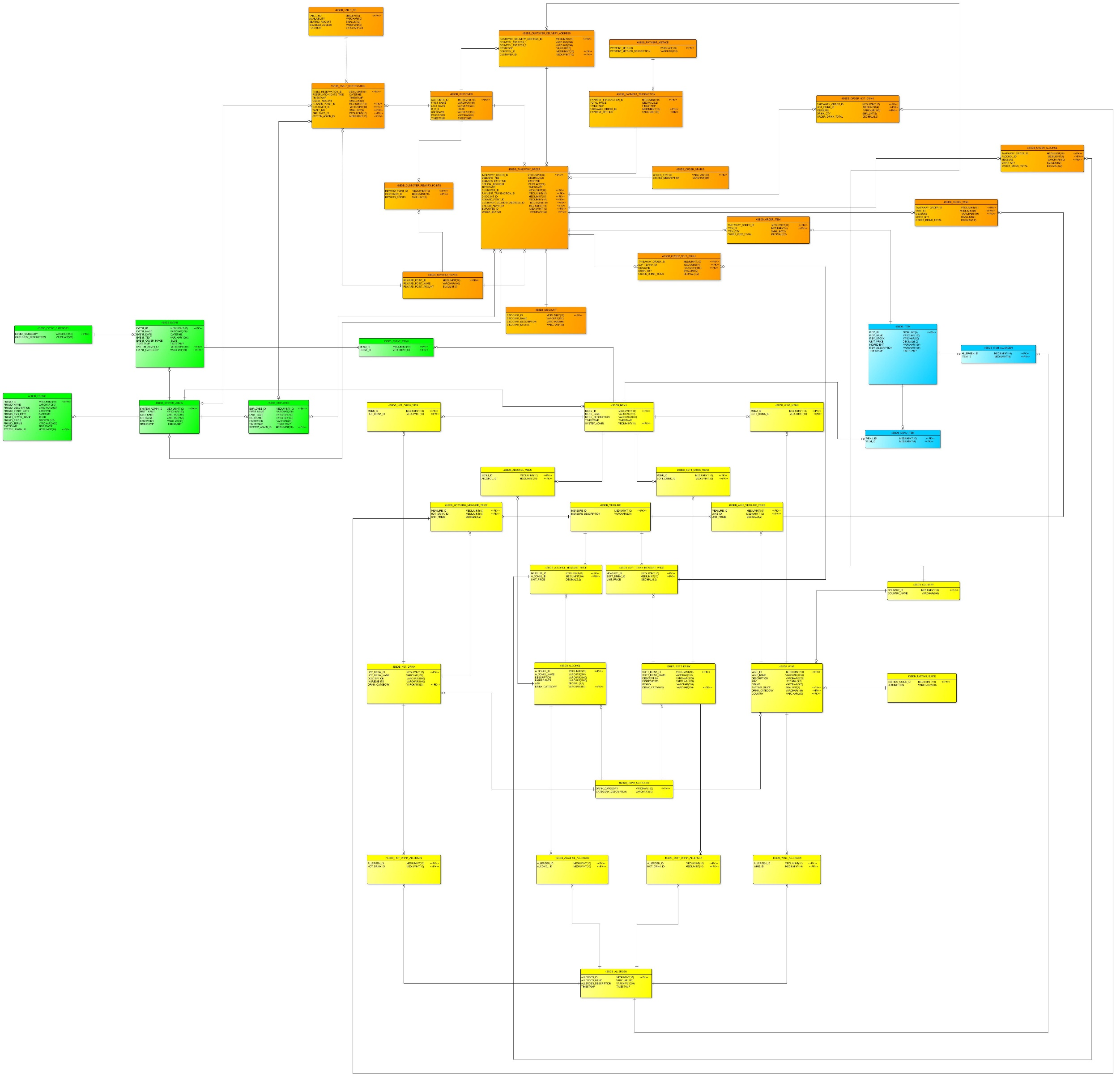The ERD is segmented into the following userviews: System Admin, Customer, Food and Drink. The overview ERD in this document is too small to read thus the userviews have been segmented for this report in the following headings.

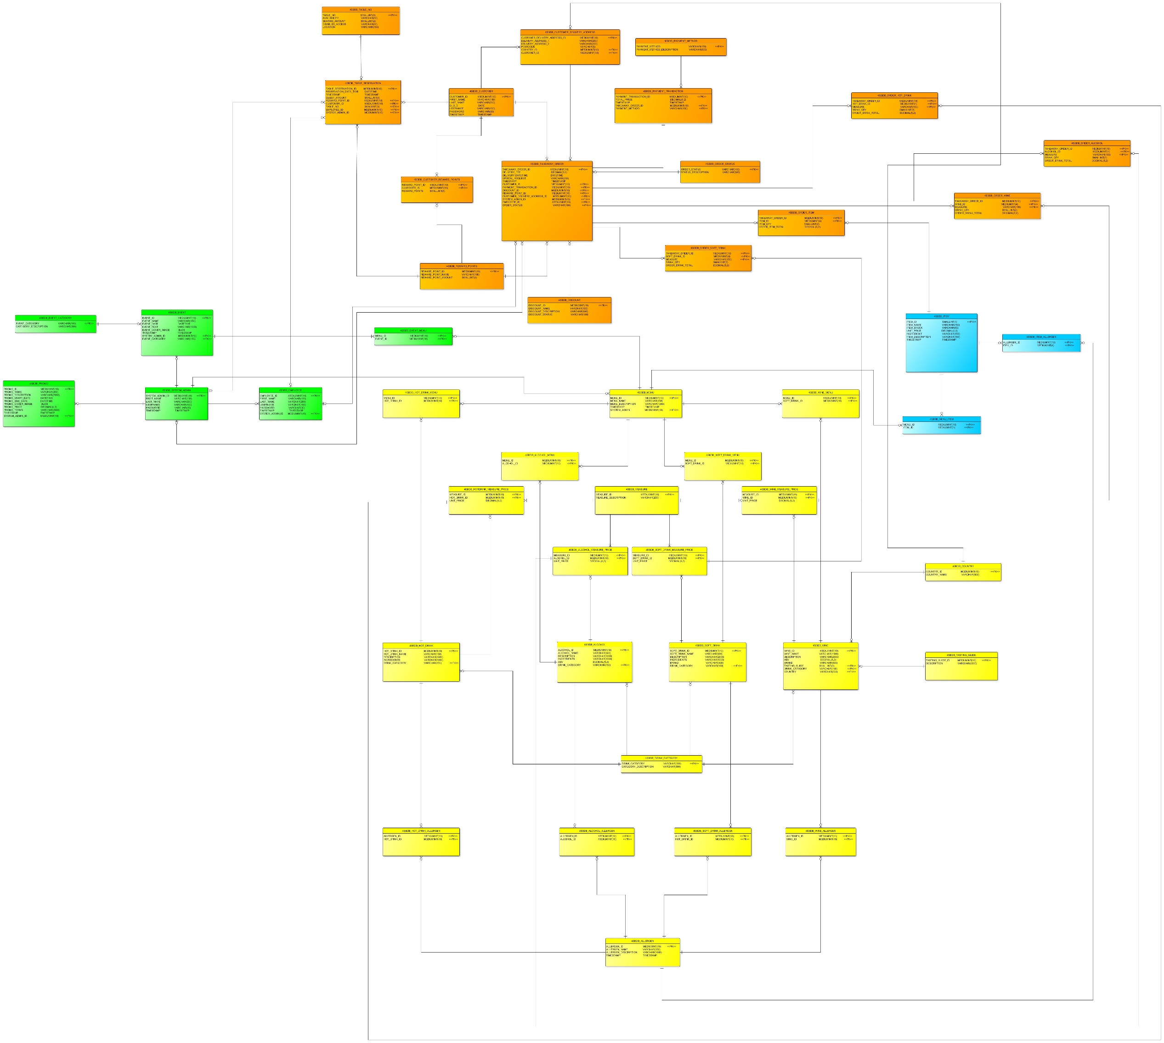

#### 3.5.1. Customer 3NF ERD

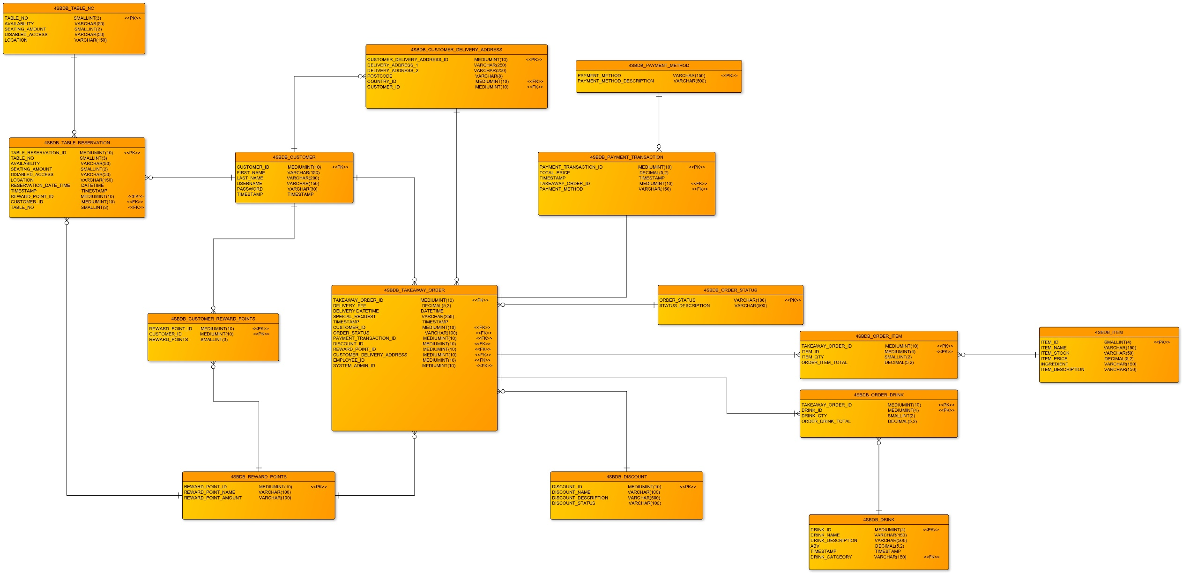

#### 3.5.2. Drinks 3NF ERD

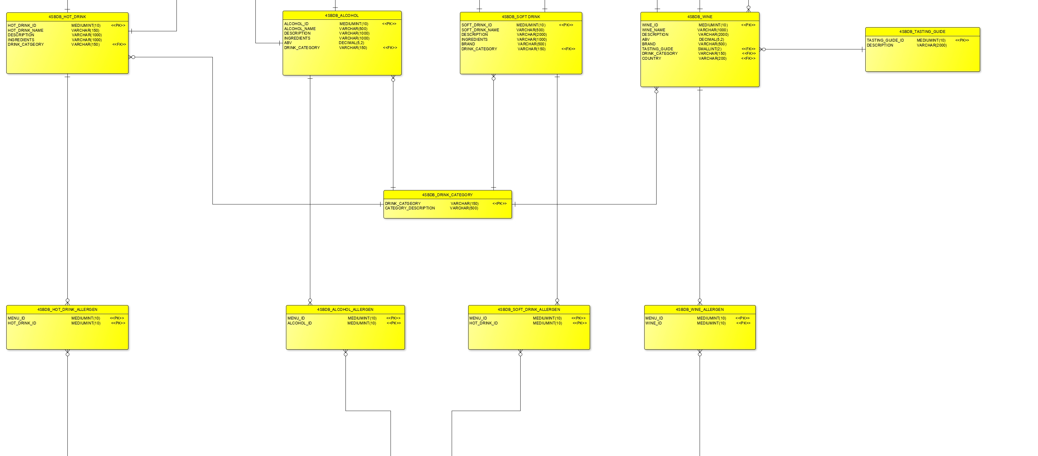

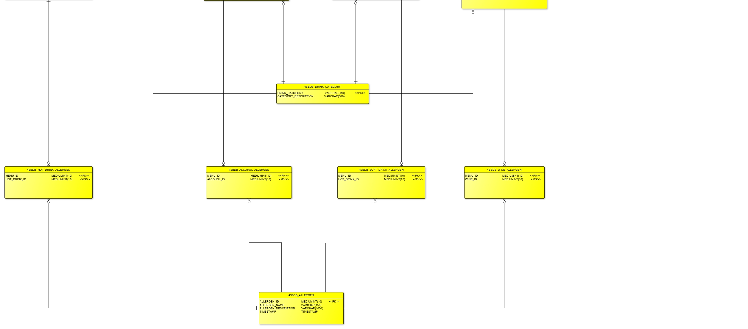

#### 3.5.3. Food 3NF ERD

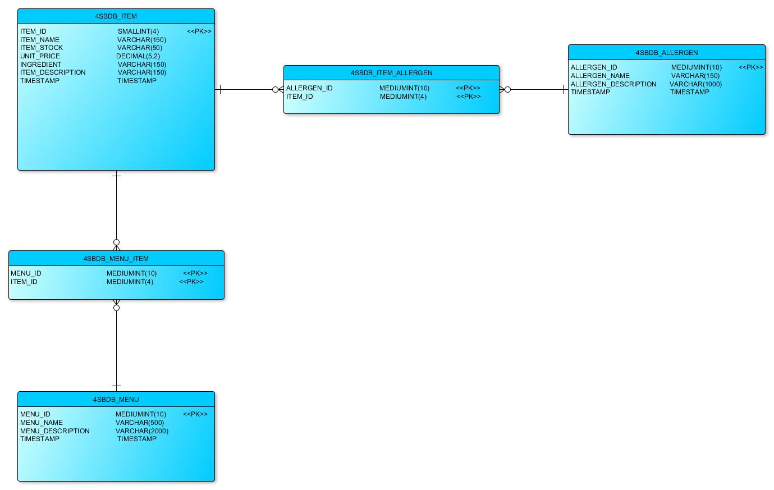

#### 3.5.4. System Admin 3NF ERD

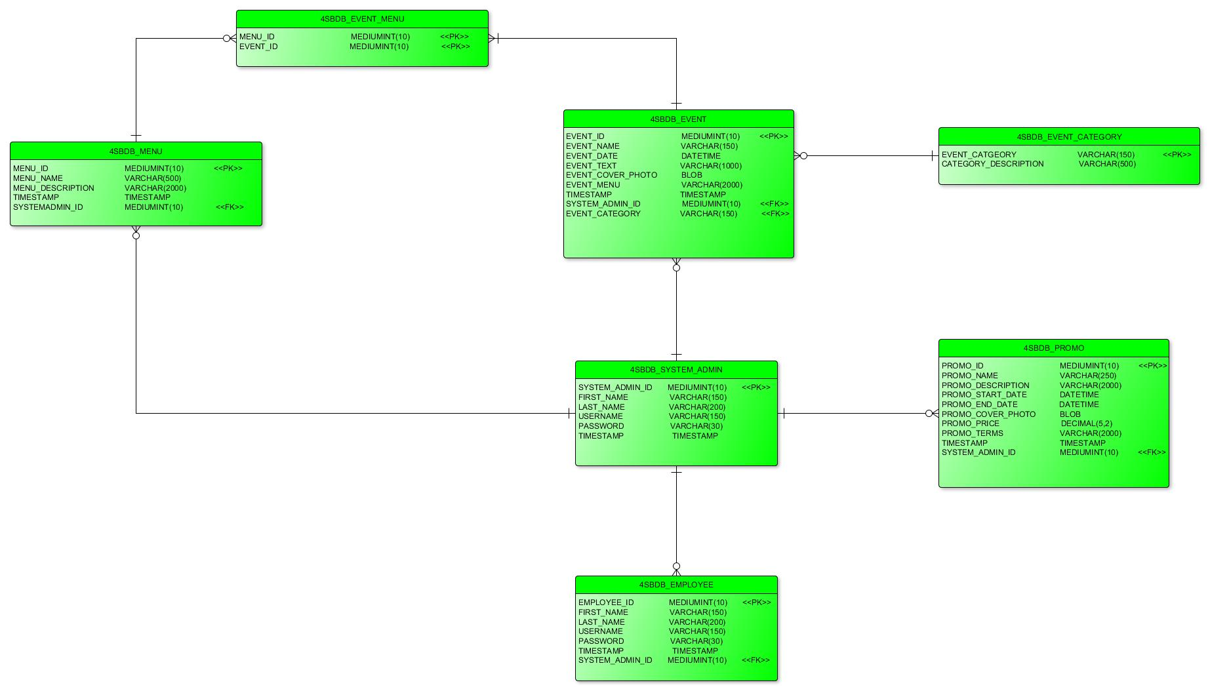

## 3.6 Entity Relationship Matrix

## 3.7 Product Boundary

This diagram encompasses the scope and limits of the product.

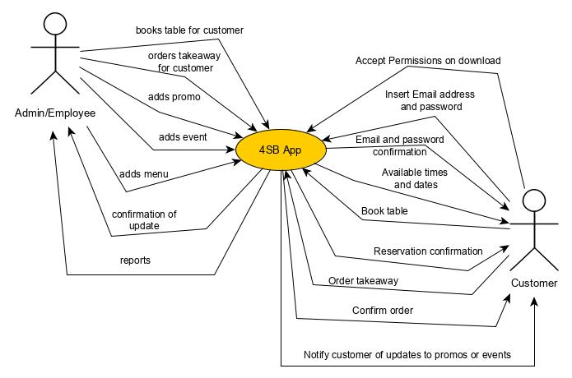

## Product Use Case Table

|  |  |  |  |  |
| --- | --- | --- | --- | --- |
| **BUC No** | **PUC No** | **PUC Name** | **Actor/s** | **Input & Output** |
| #1 | 1 | Increase increment for amount of times app is ‘downloaded’ | Customer | Click download and accepts permission (Input)  Receives app (Output) |
| #2 | 2.1 | Customer subscribes details to 4SB app [enters valid email and password] | Customer | New customer record (input)  Receives conformation of record in the form of an email (output) |
| #2 | 2.2 | Customer verifies email address via confirmation email. | Customer | Verification link clicked (input)  Email address and password verified and validated (output) |
| #3 | 3 | Customer reserves table | Customer | Time and Date required (input)  Available tables (output) |
| #3 | 3.1 | Customer receives confirmation on table reservation | Customer | Confirmation of table reservation summary (input)  Confirmation email sent to customer (output) |
| #4 | 4 | Customer orders a takeaway to be delivered | Customer | Inputs takeaway order details (input)  Contents Verified and validated (output) |
| #4 | 4.1 | Customer submits electronic payment | Customer | Record verified (input)  Confirmation email sent (output) |
| #4 | 4.2 | Order record created | Admin | Record verified (input)  Record saved (output) |
| #4 | 4.3 | Admin notified of order | Admin | Record verified (input)  Notification sent to admin (output) |
| #5 | 5 | System Admin creates daily/weekly/monthly reports | Admin | Report type selected (input)  Receives report in pdf (output) |
| #6-7 | 6-7 | Follows the same protocol as 3 and 4 but initiated by the admin on behalf of customer | Admin |  |
| #8 | 8 | Add Menu record | Admin | Menu items, description and name are input (input)  Receives confirmation of input. |
| #9 | 9 | Add Promo record | Admin | Promotion details are added (input)  Receives confirmation of successful input and notifies customers (output) |
| #10 | 10 | Add Event record | Admin | New event details (input)  Receives confirmation of event input and notifies customers (output) |
| #11 | 11 | Add employee record | Admin | Employee details added (input)  Receives confirmation of employee input (output) |
| #12 | 12 | Add item record | Admin | Item details added (input)  Receives confirmation of item input (output) |

# 4. Non-Functional Requirements

## 4.1 Appearance and style requirements

The visual house style has the following colour scheme:

|  |  |
| --- | --- |
| **Colour** | **Hex** |
| Brown | #3C3427 |
| Turquoise | #02AFAE |
| Beige | #FBFBC2 |

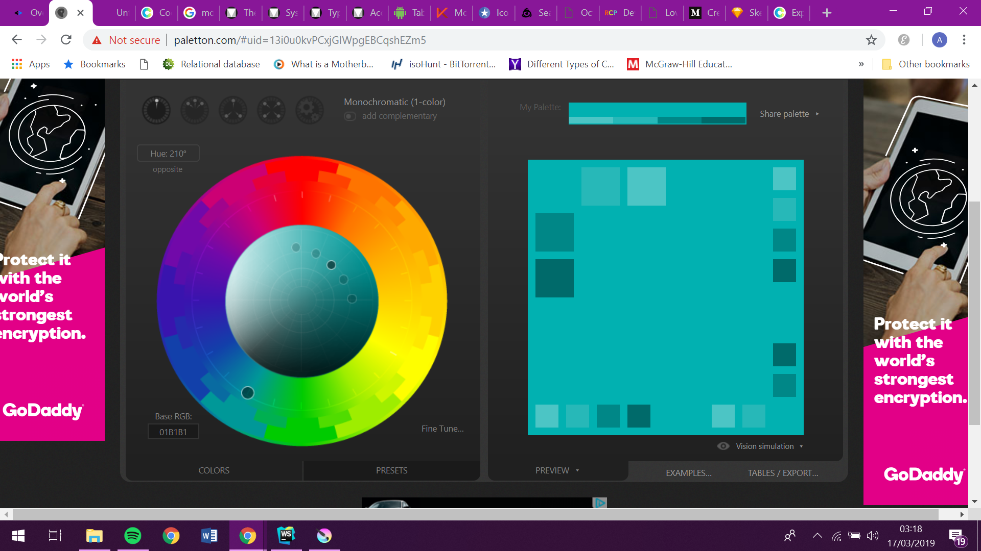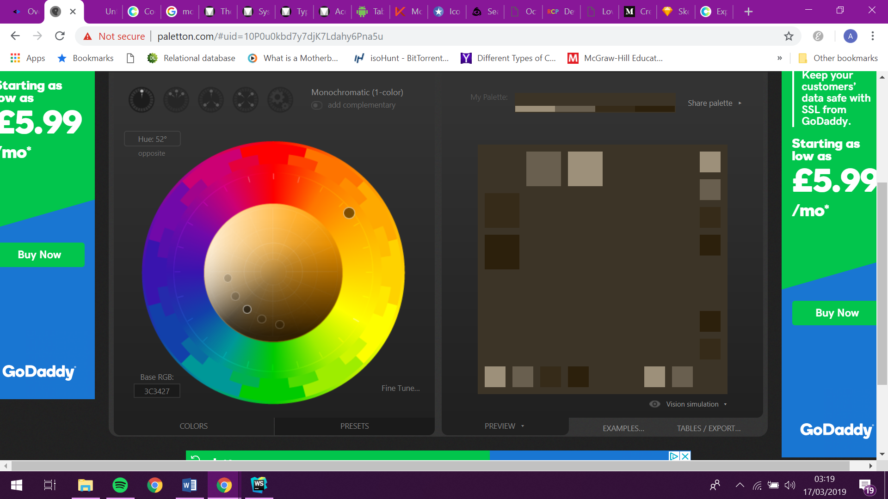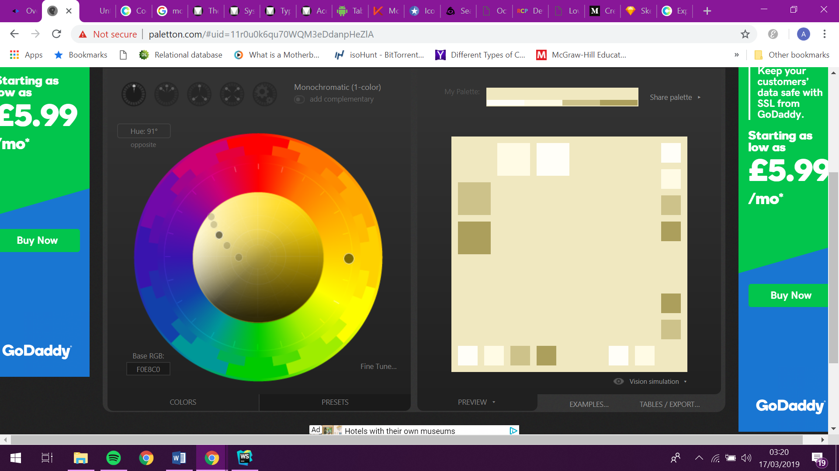

## 4.2 Wireframing

#### 4.2.1. Wireframing for Customer App

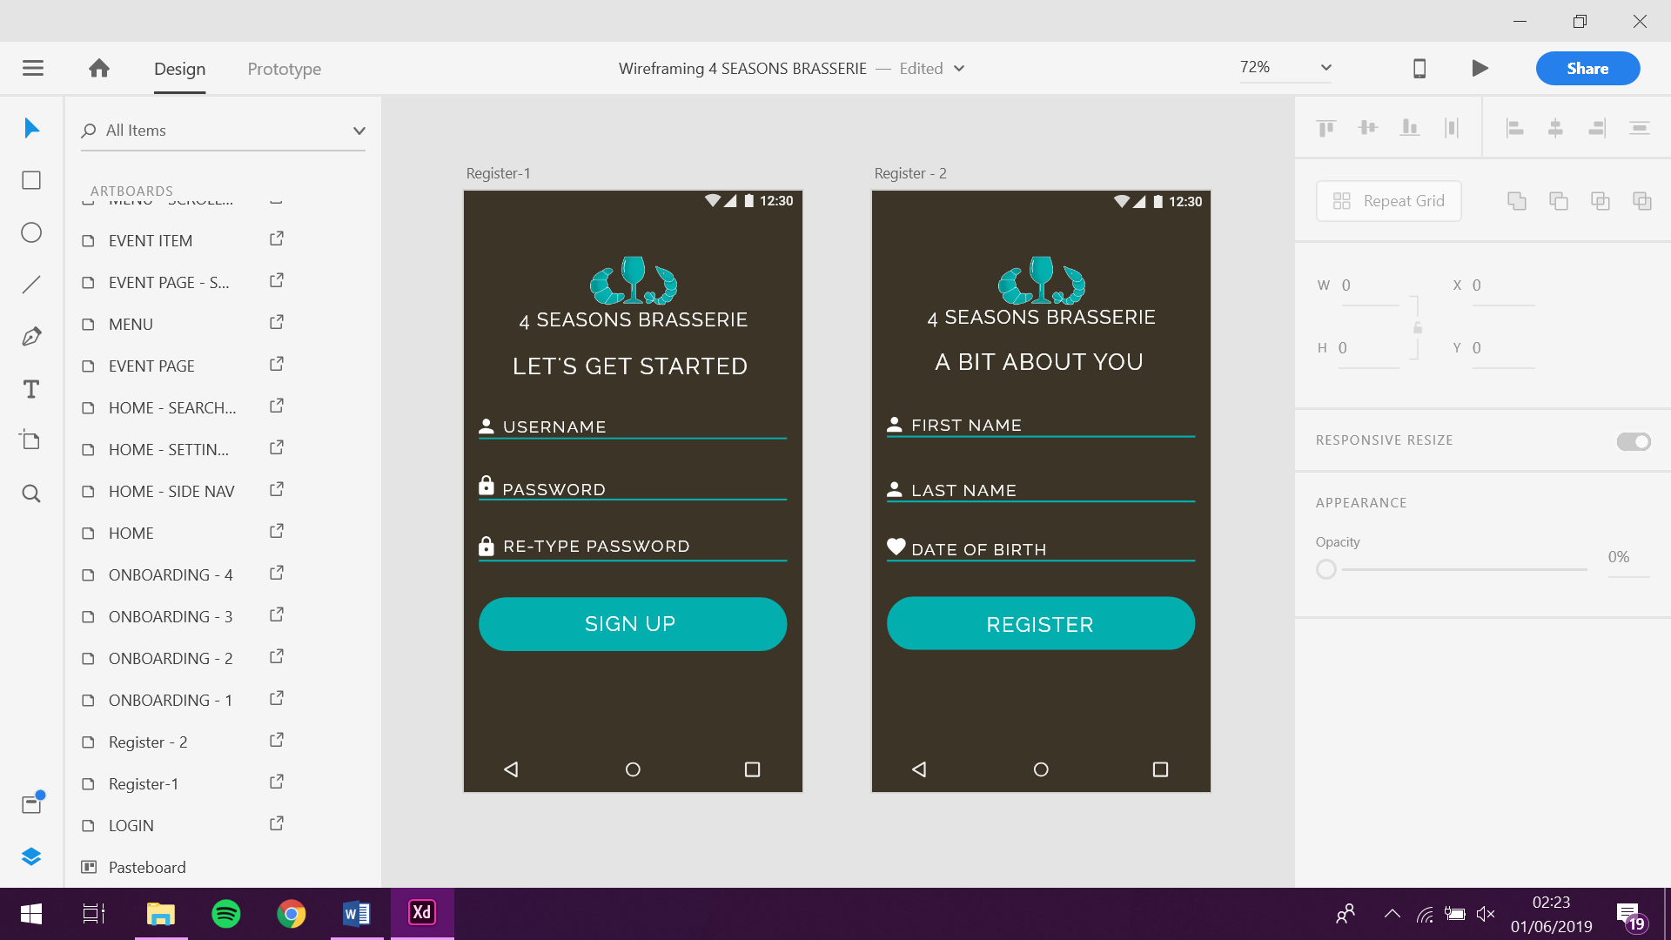

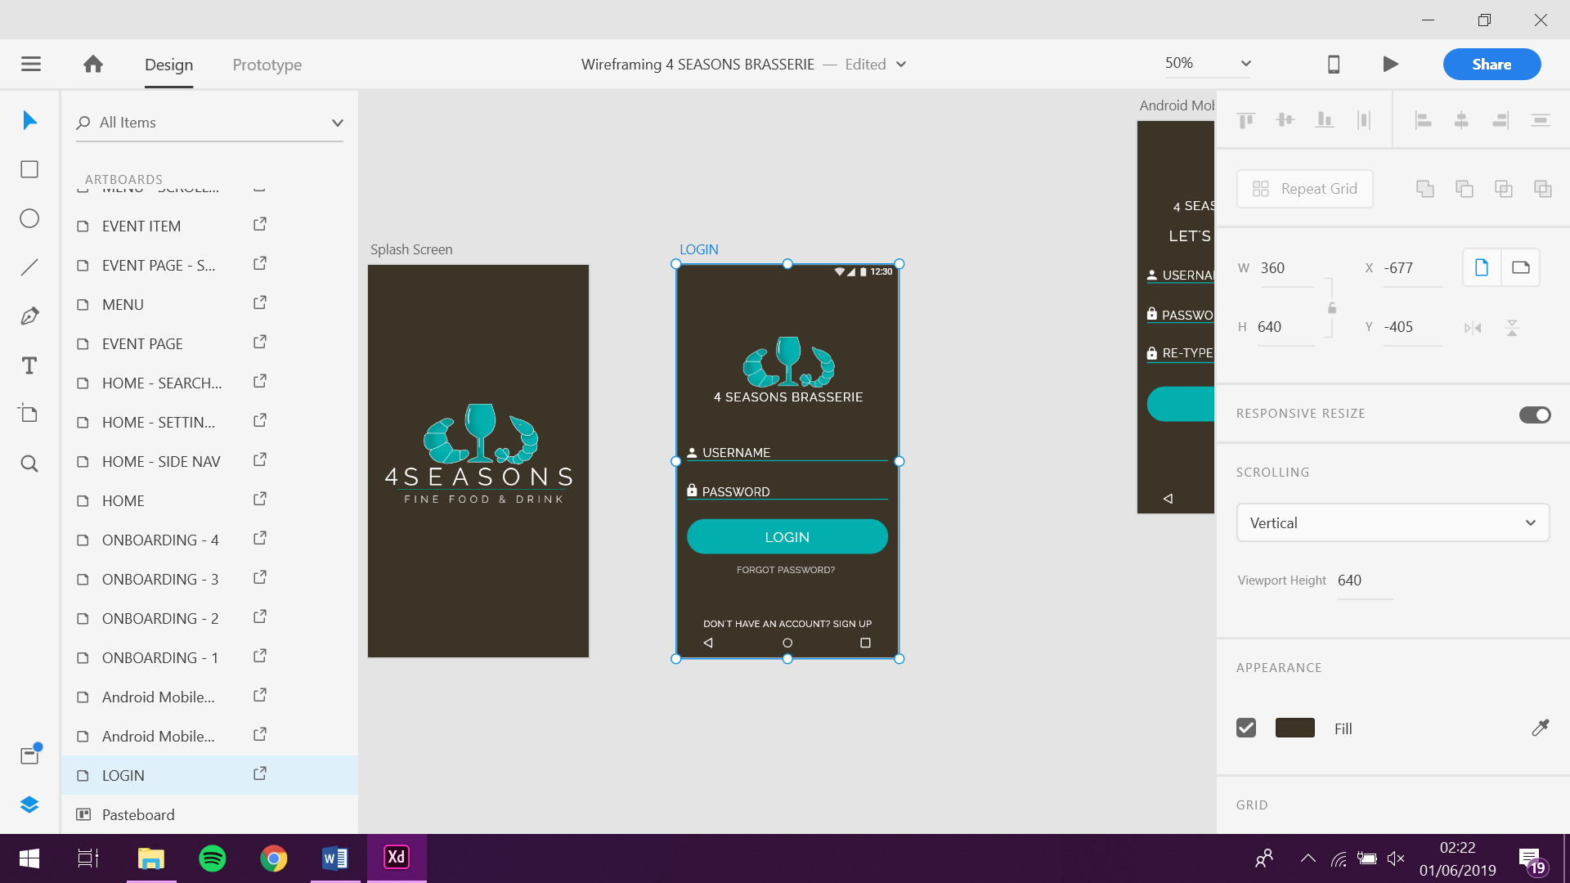

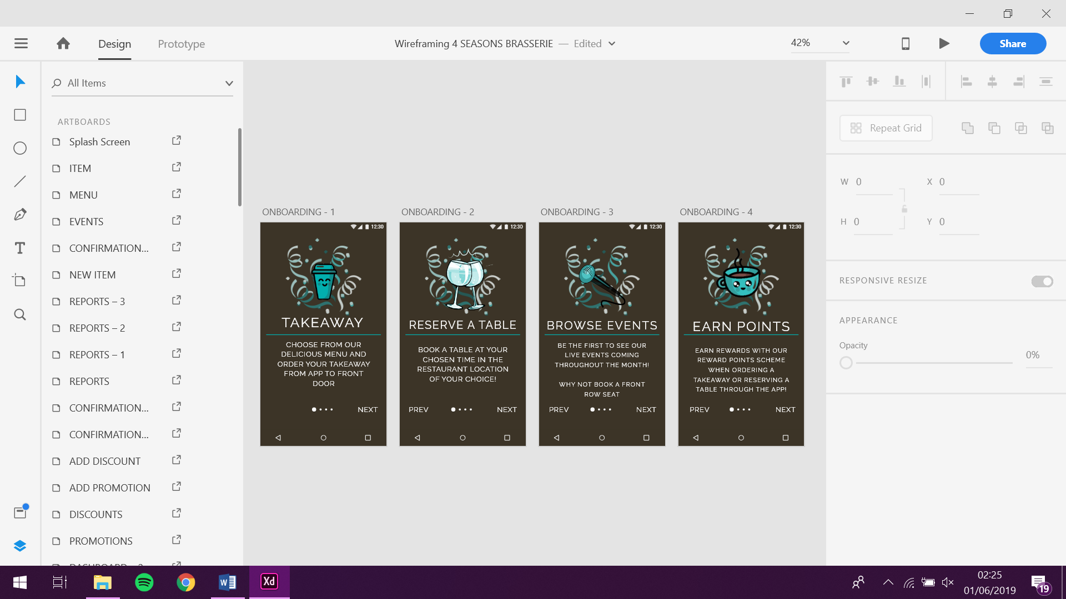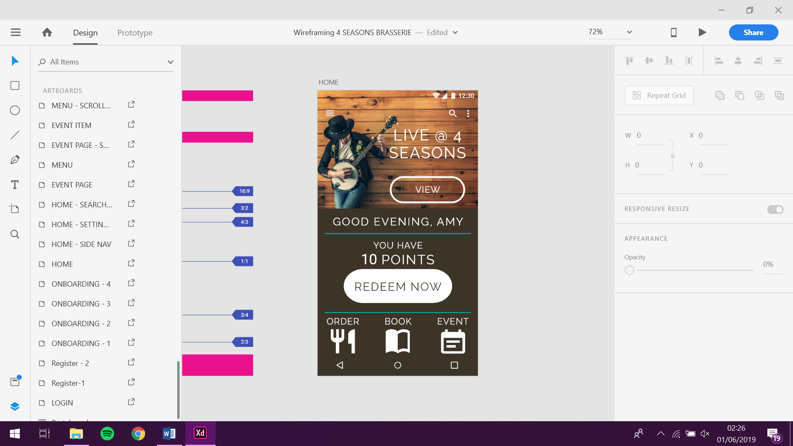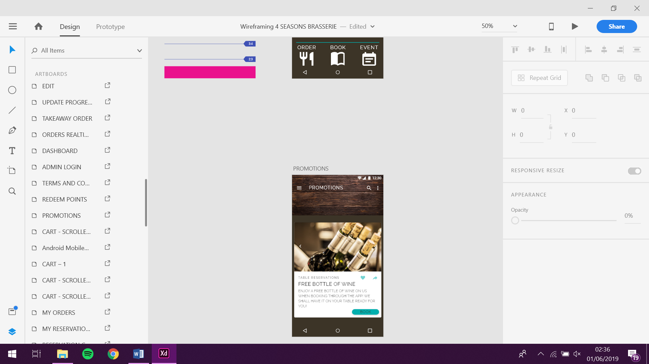

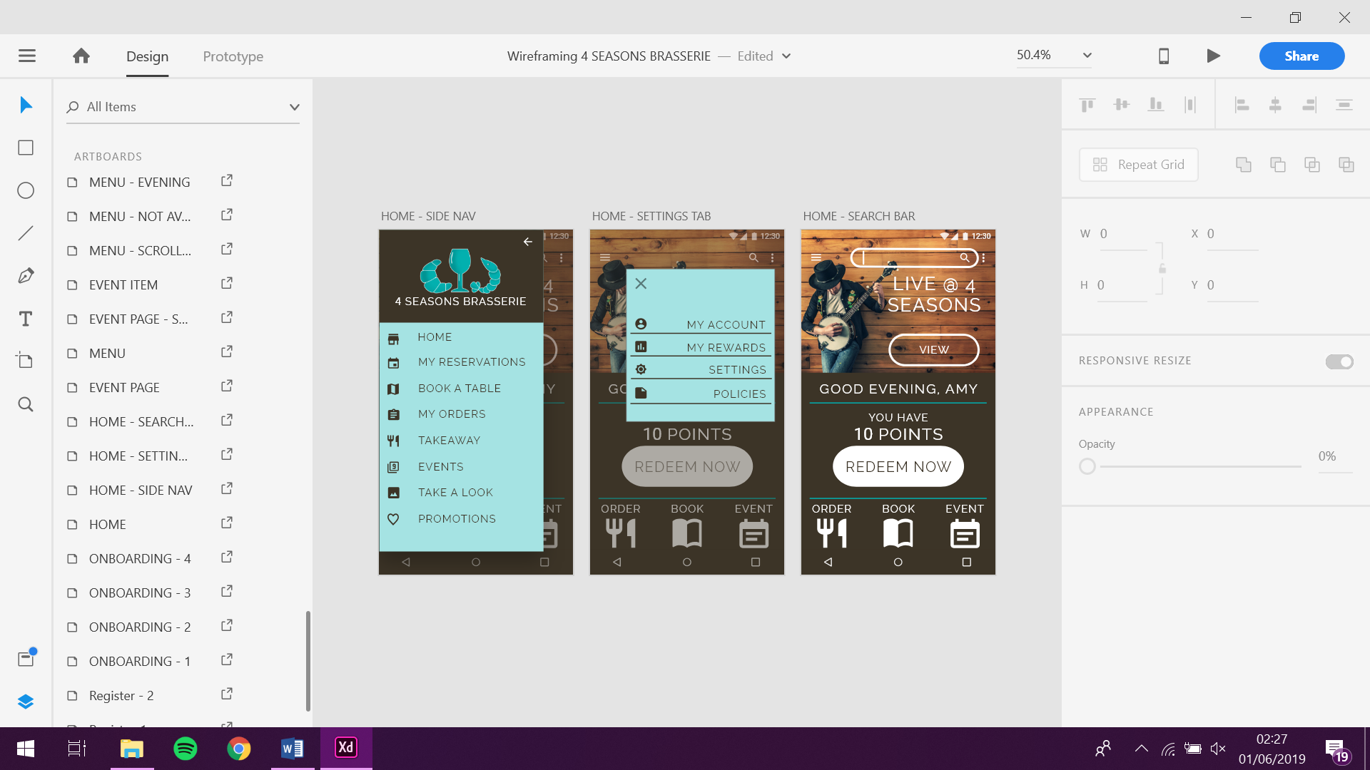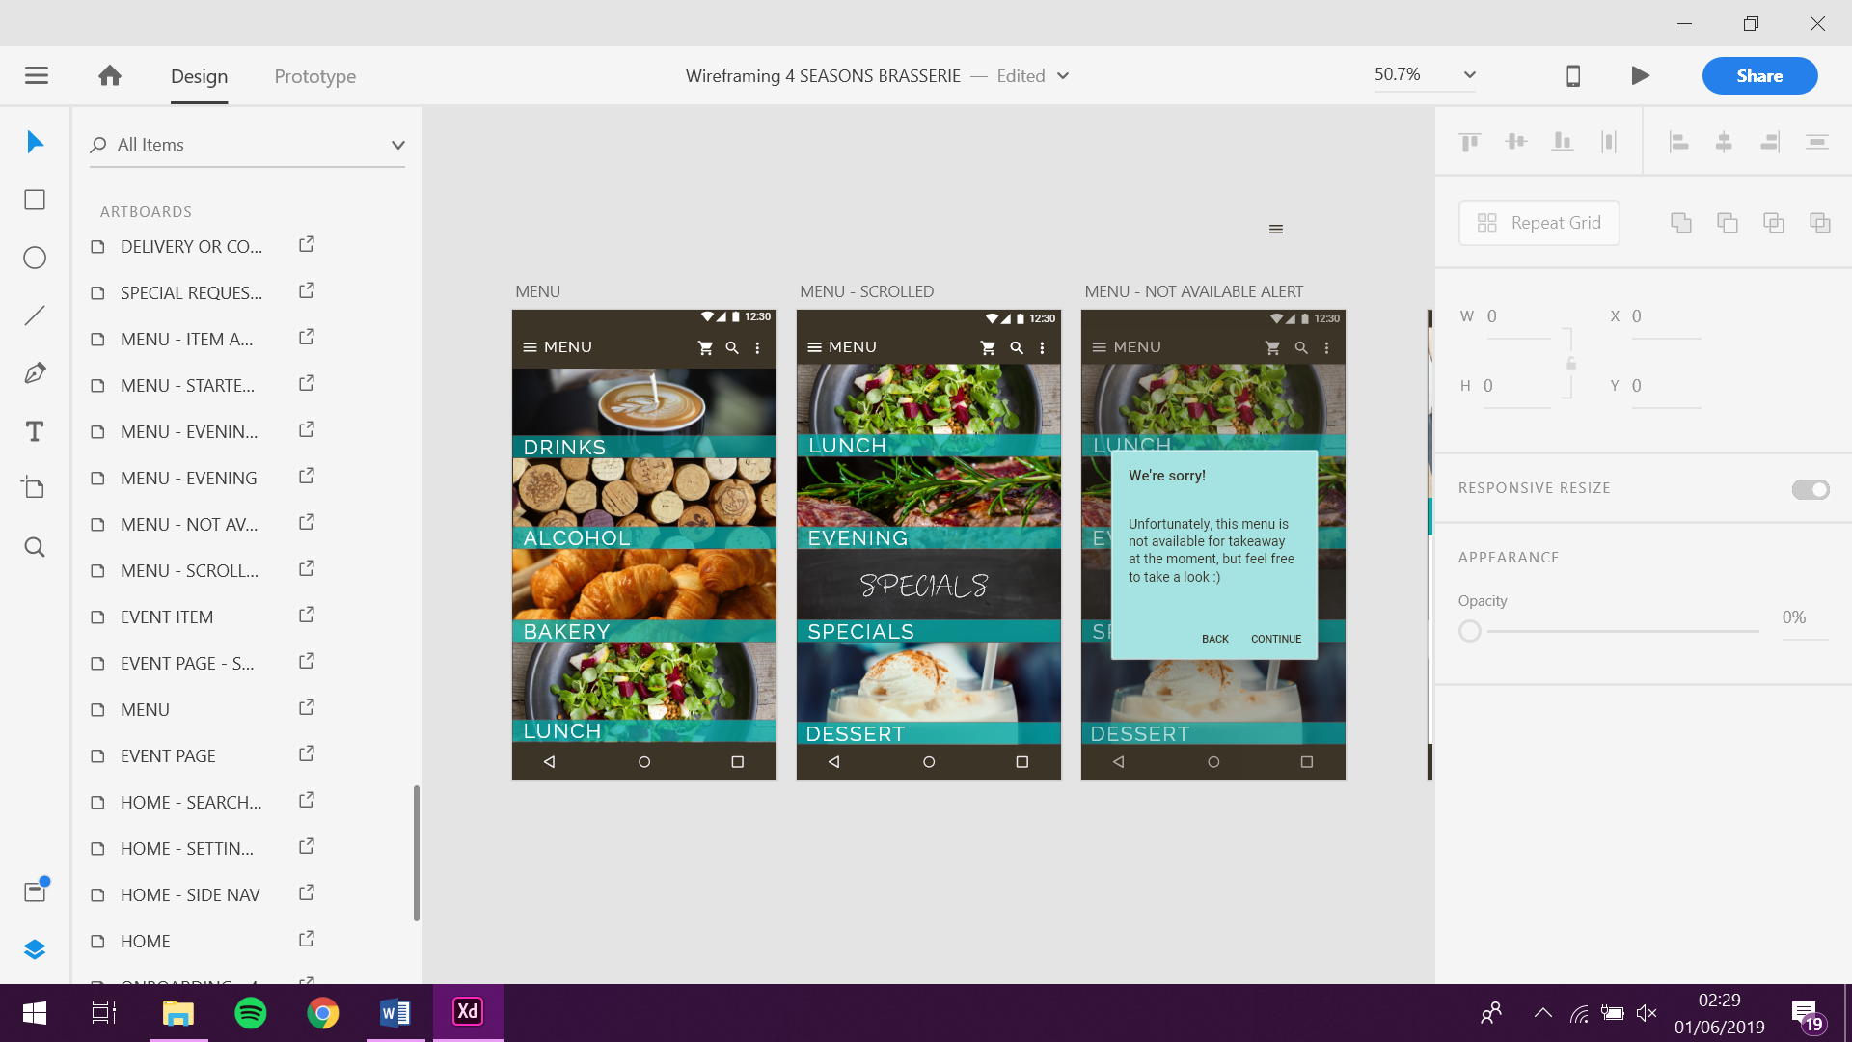

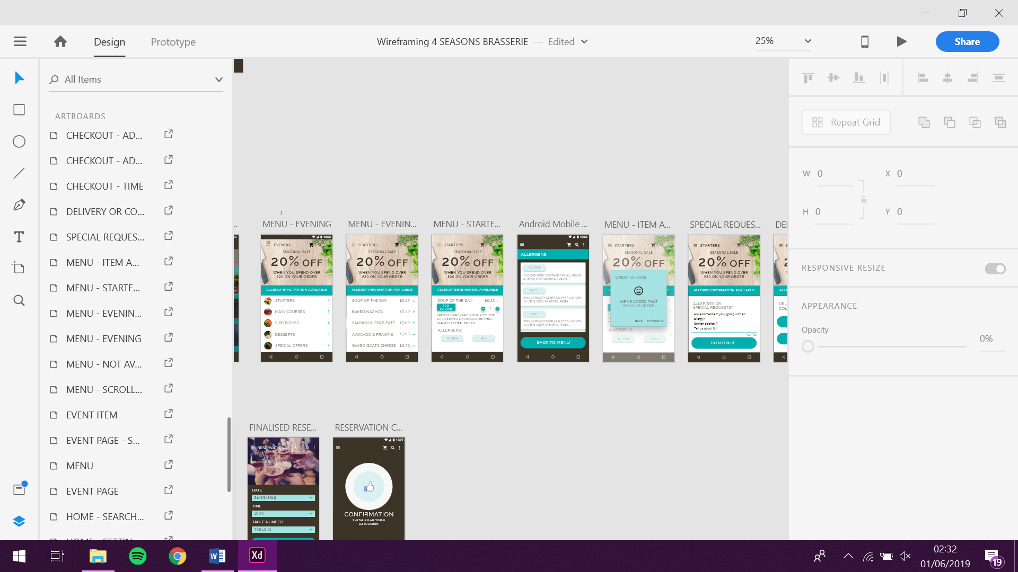

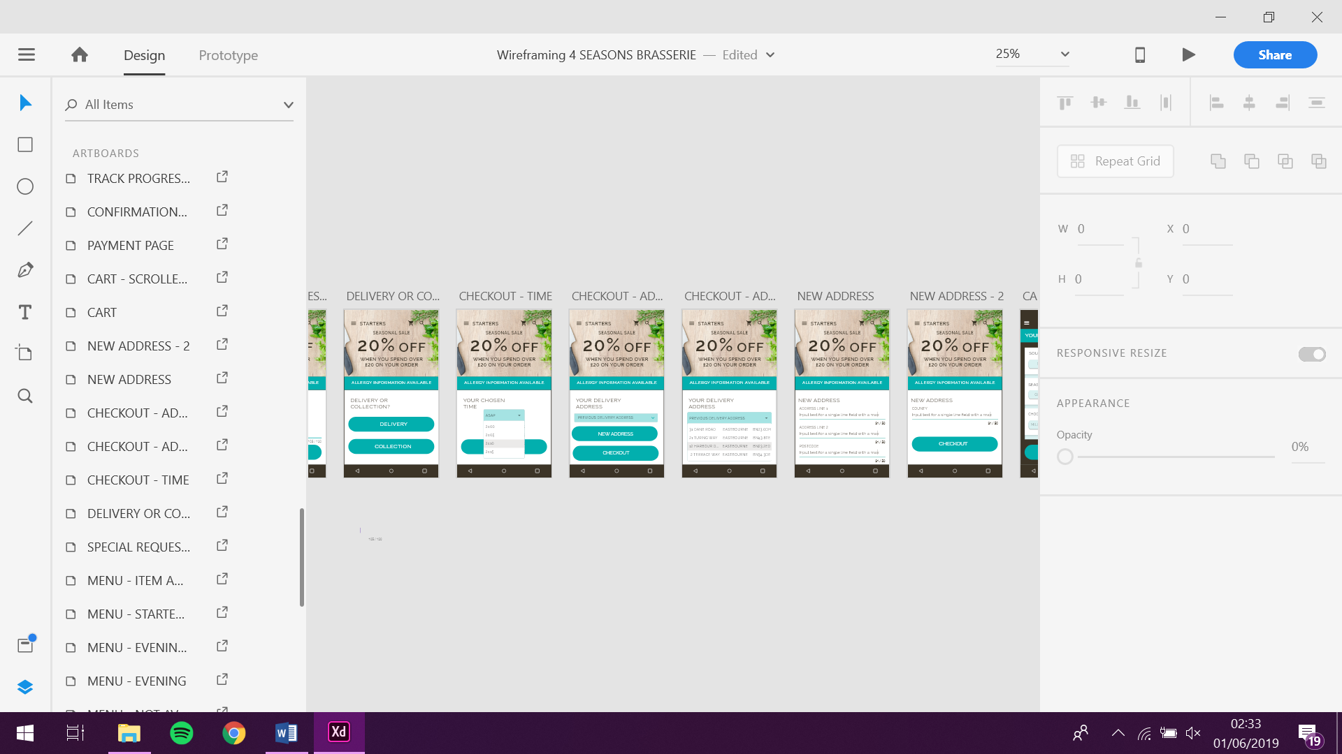

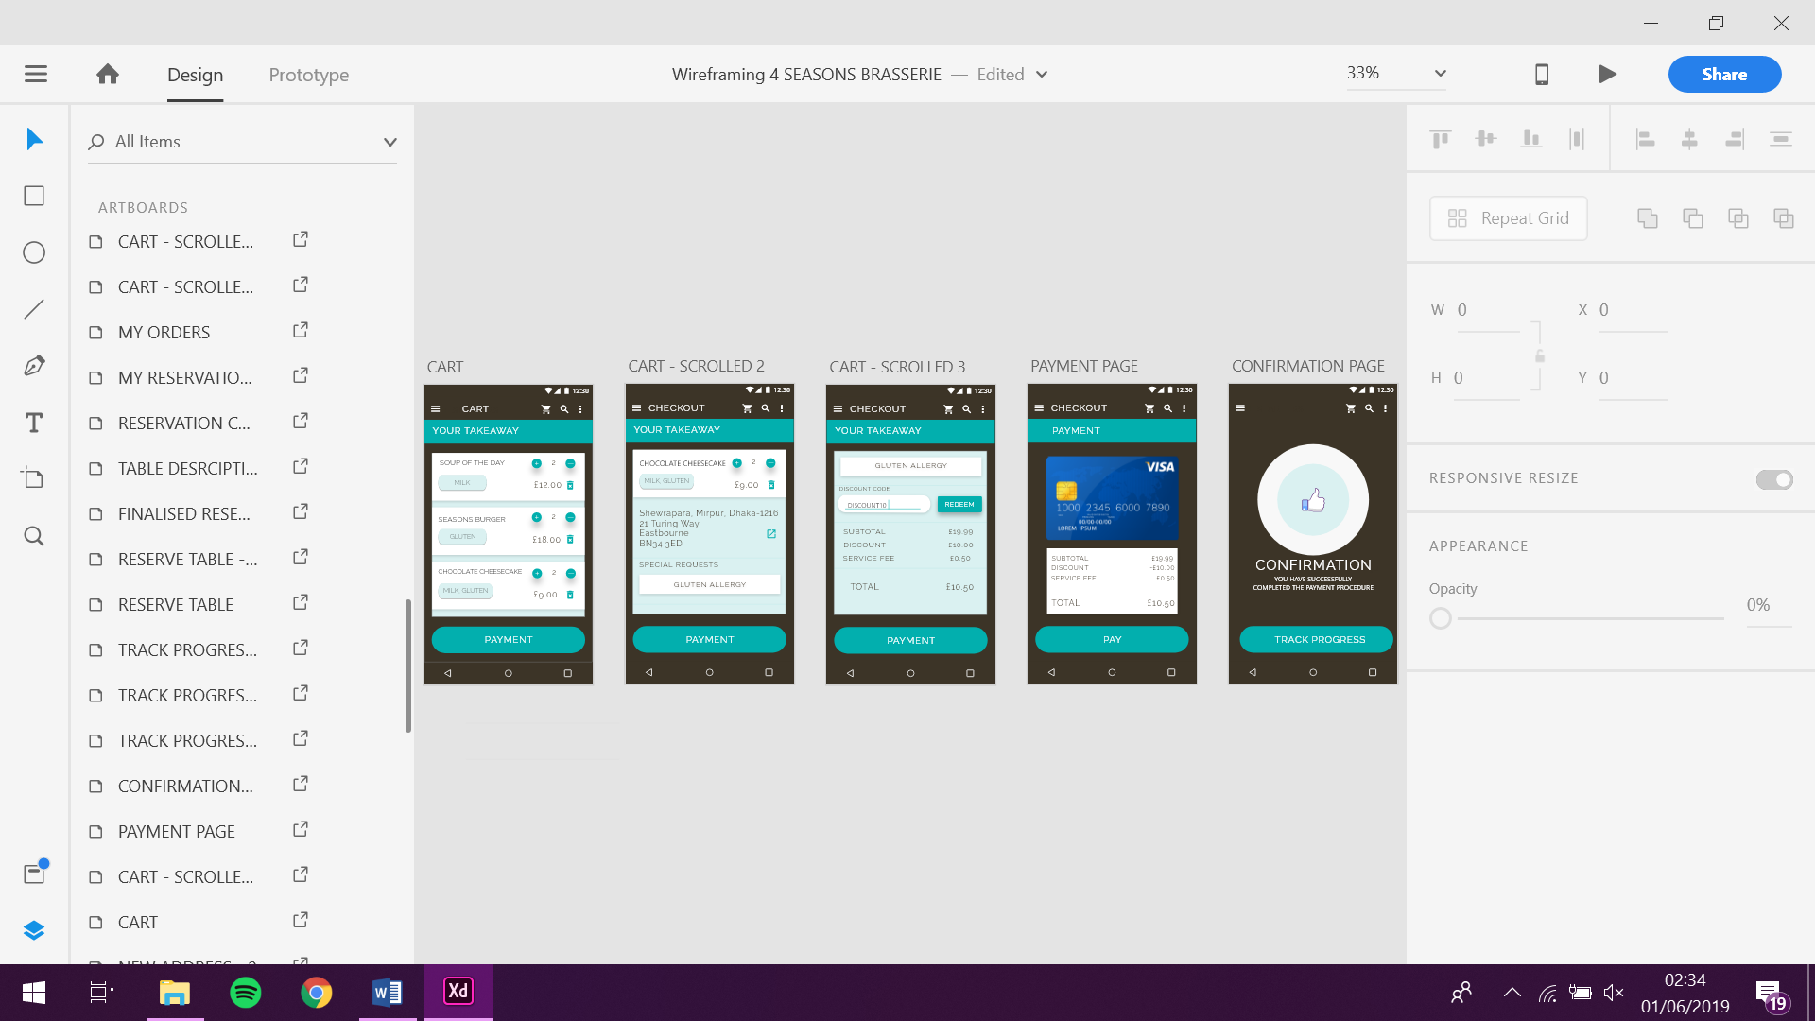

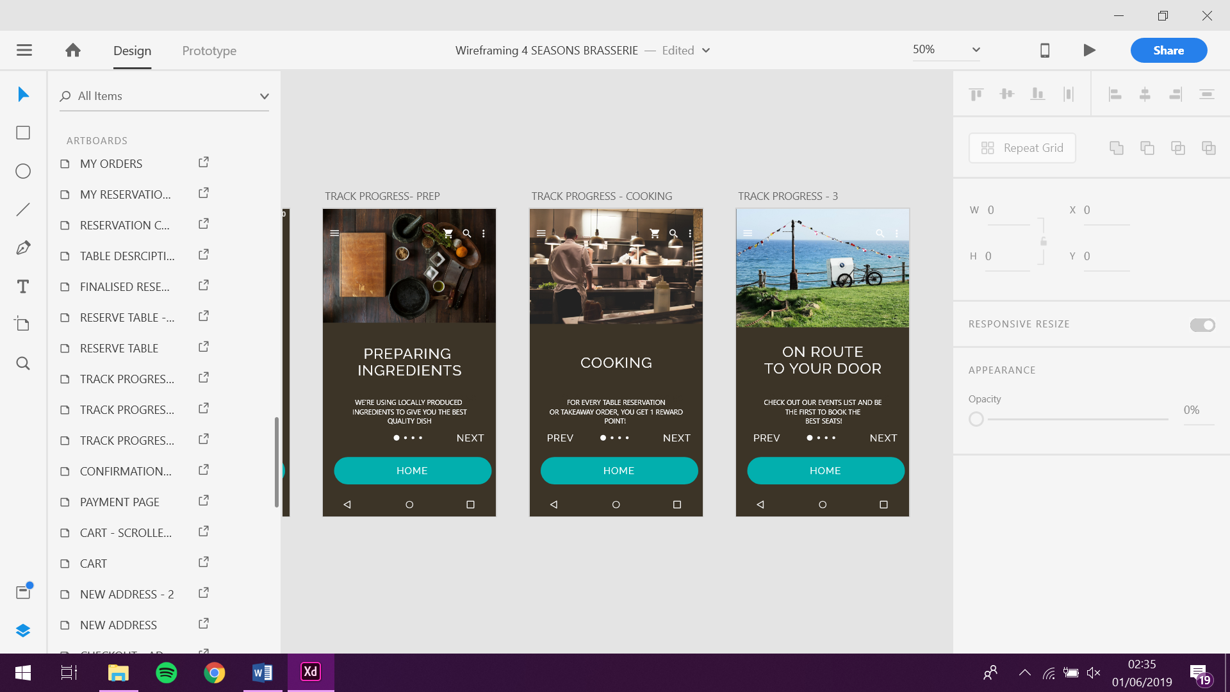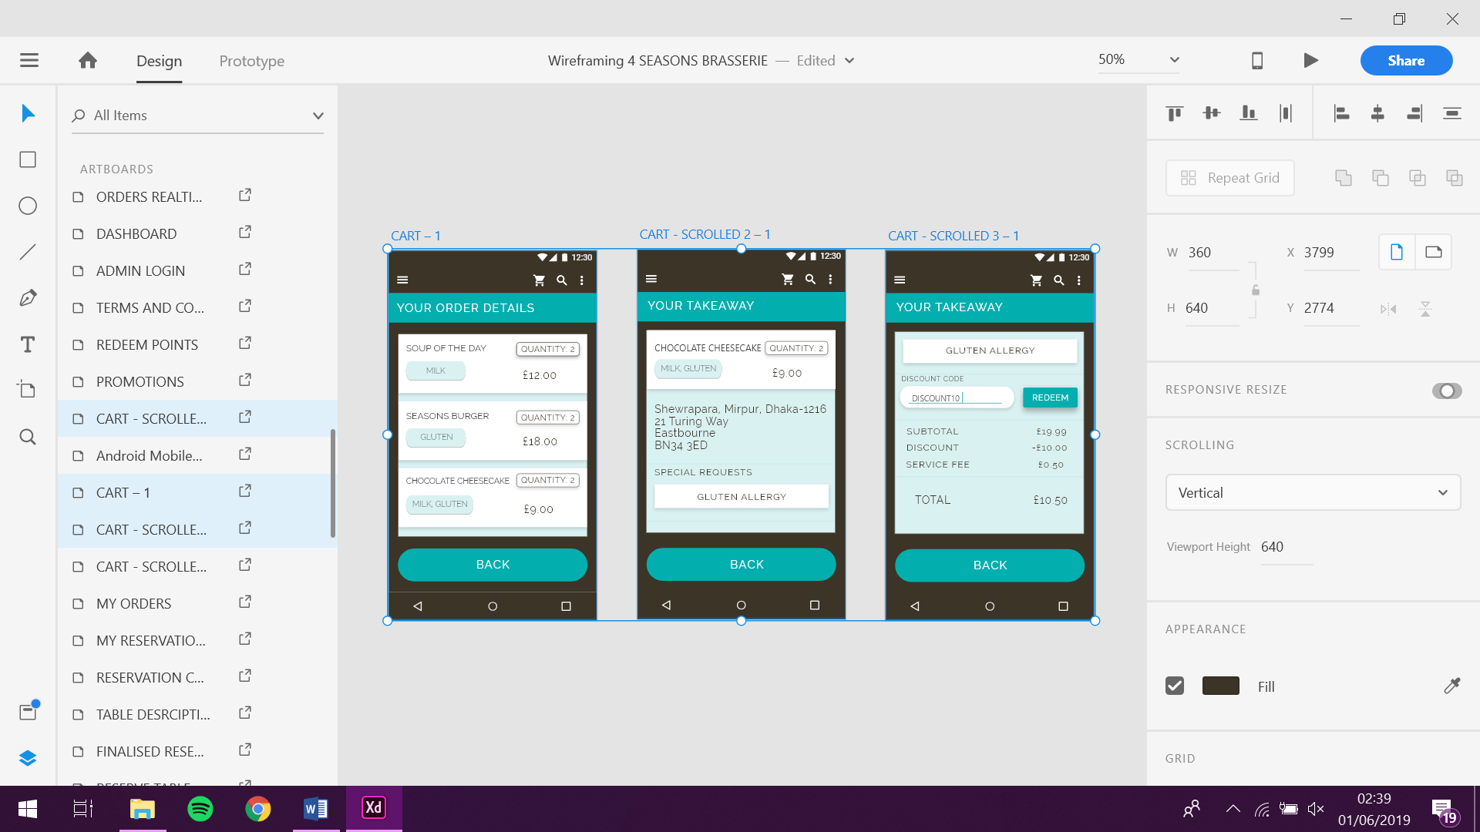

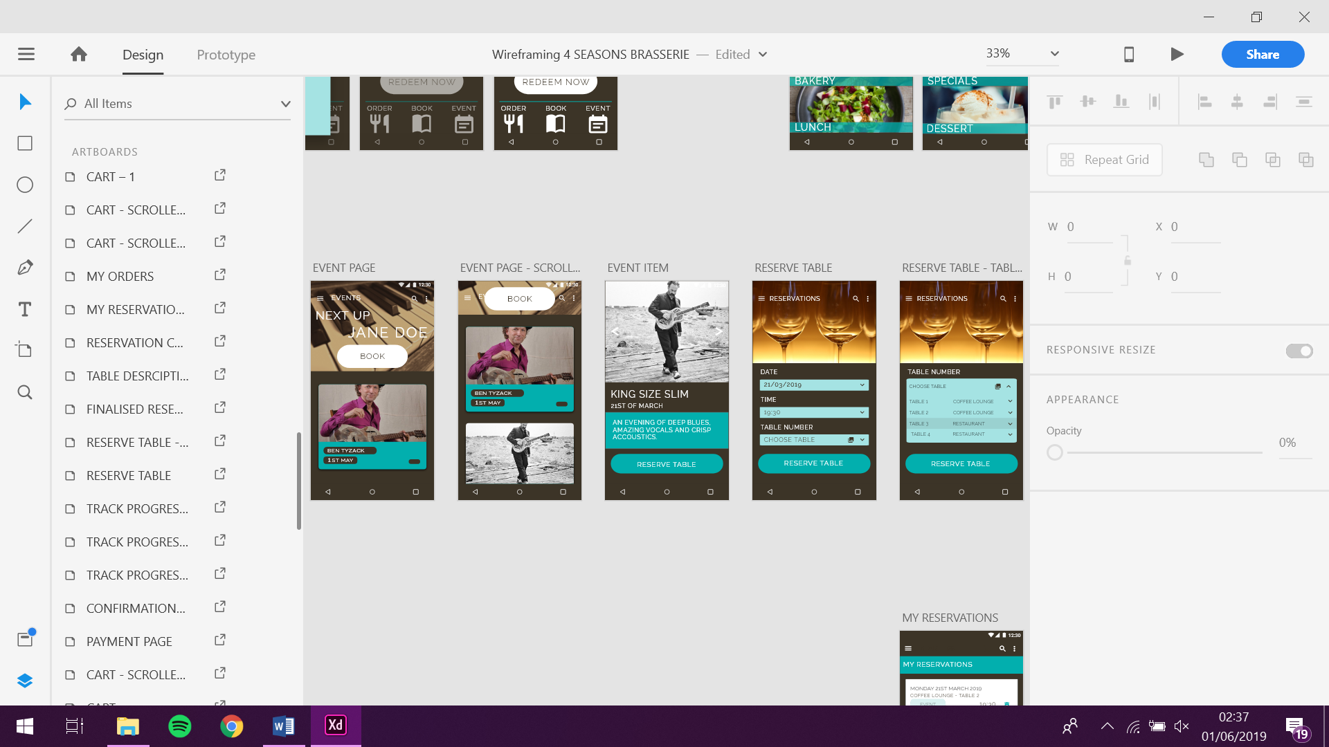

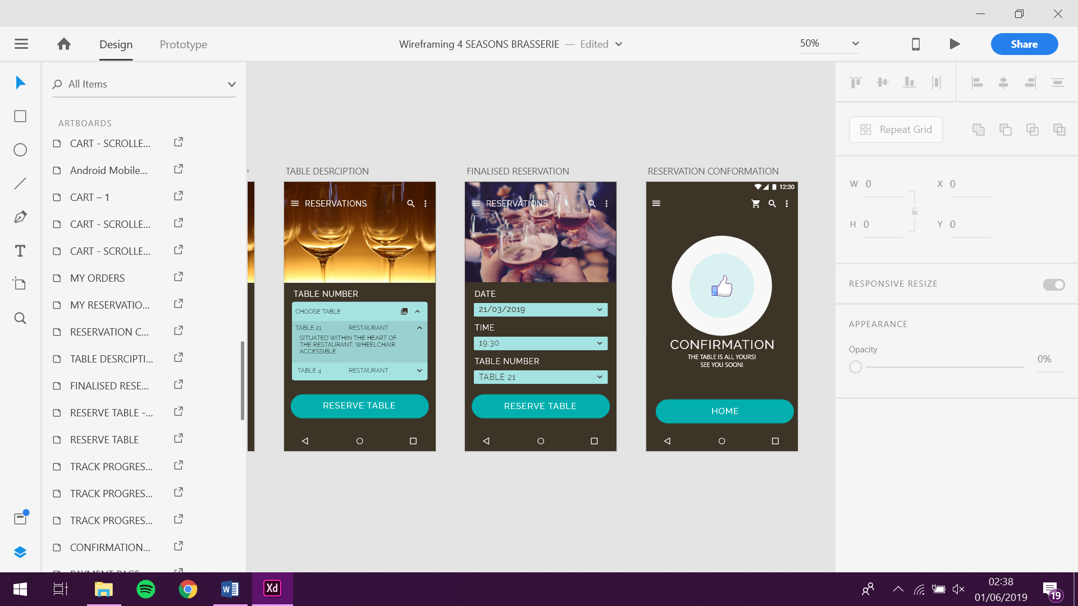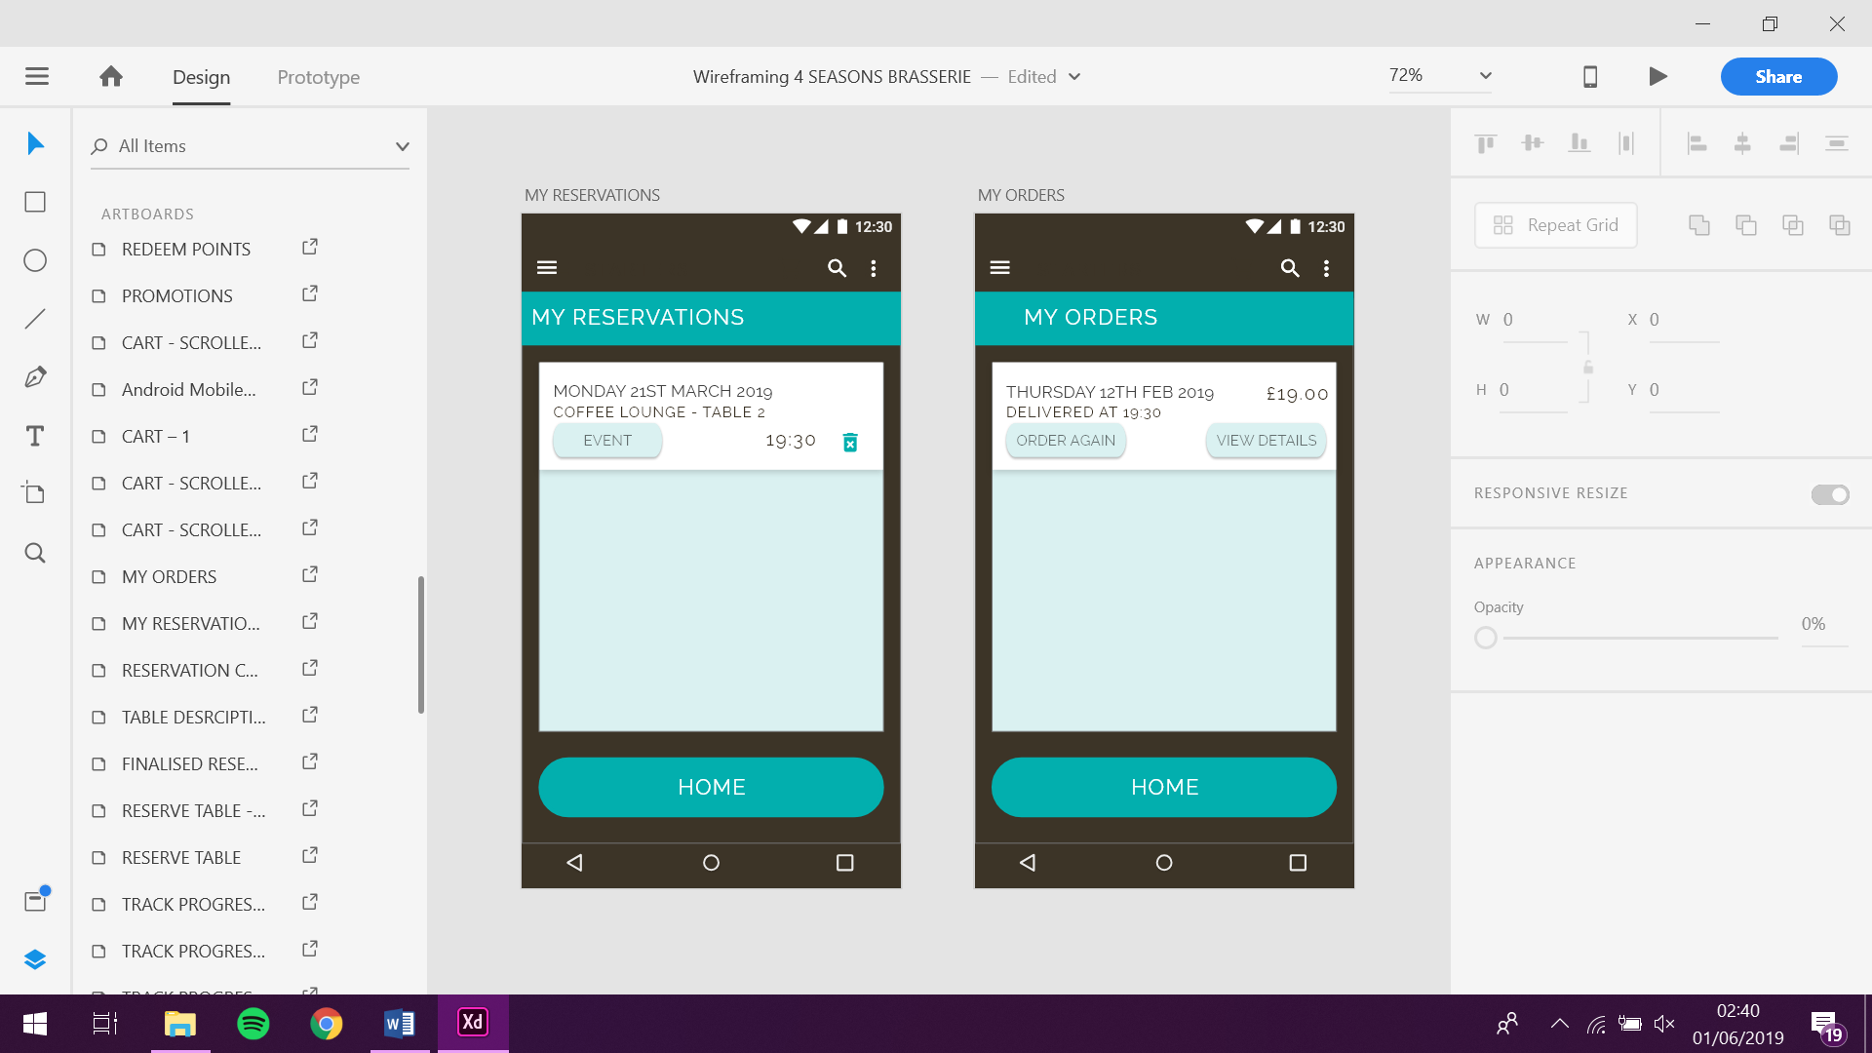

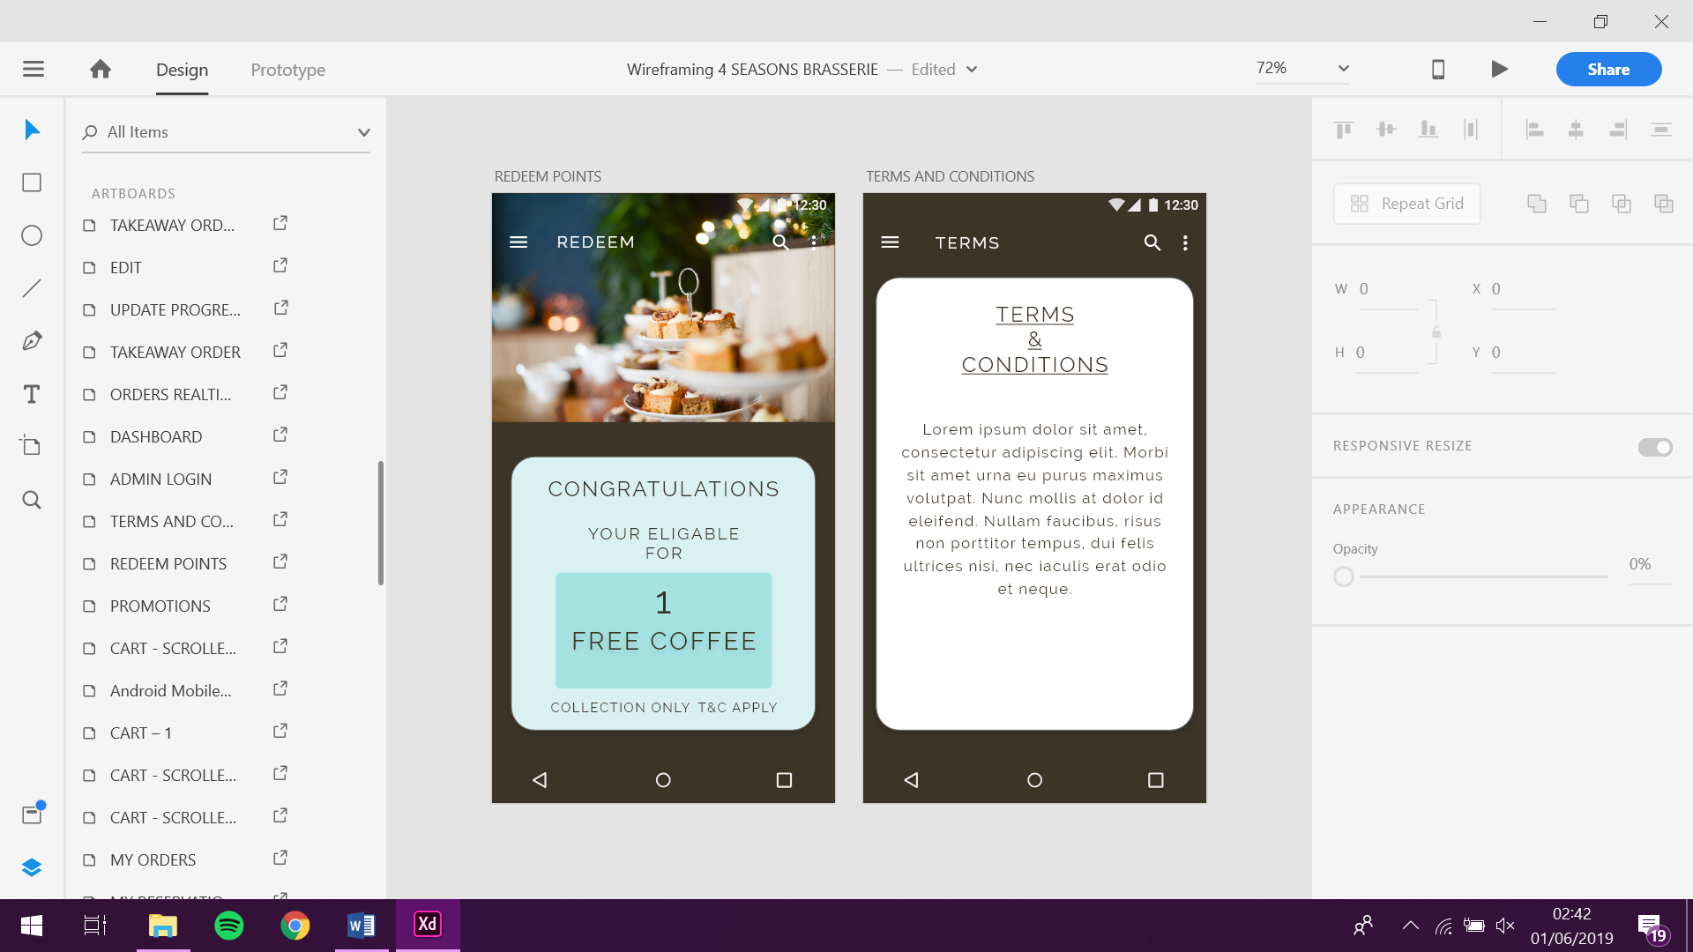

#### 4.2.2. Wireframing for Admin App

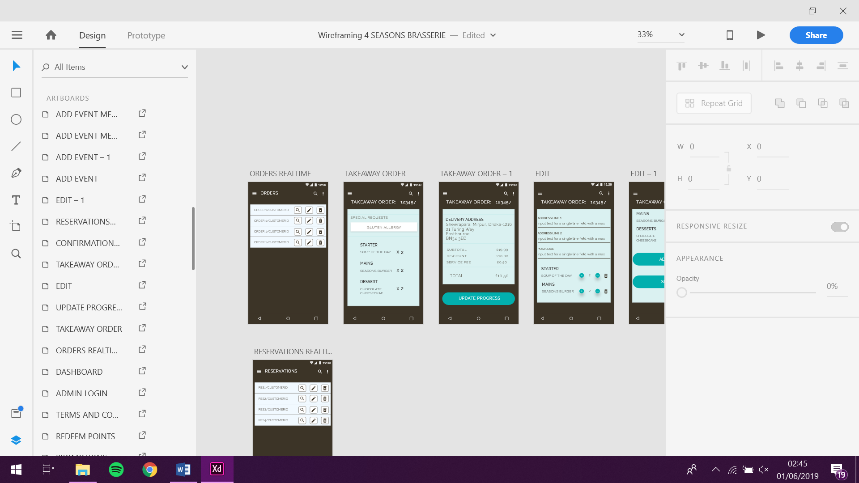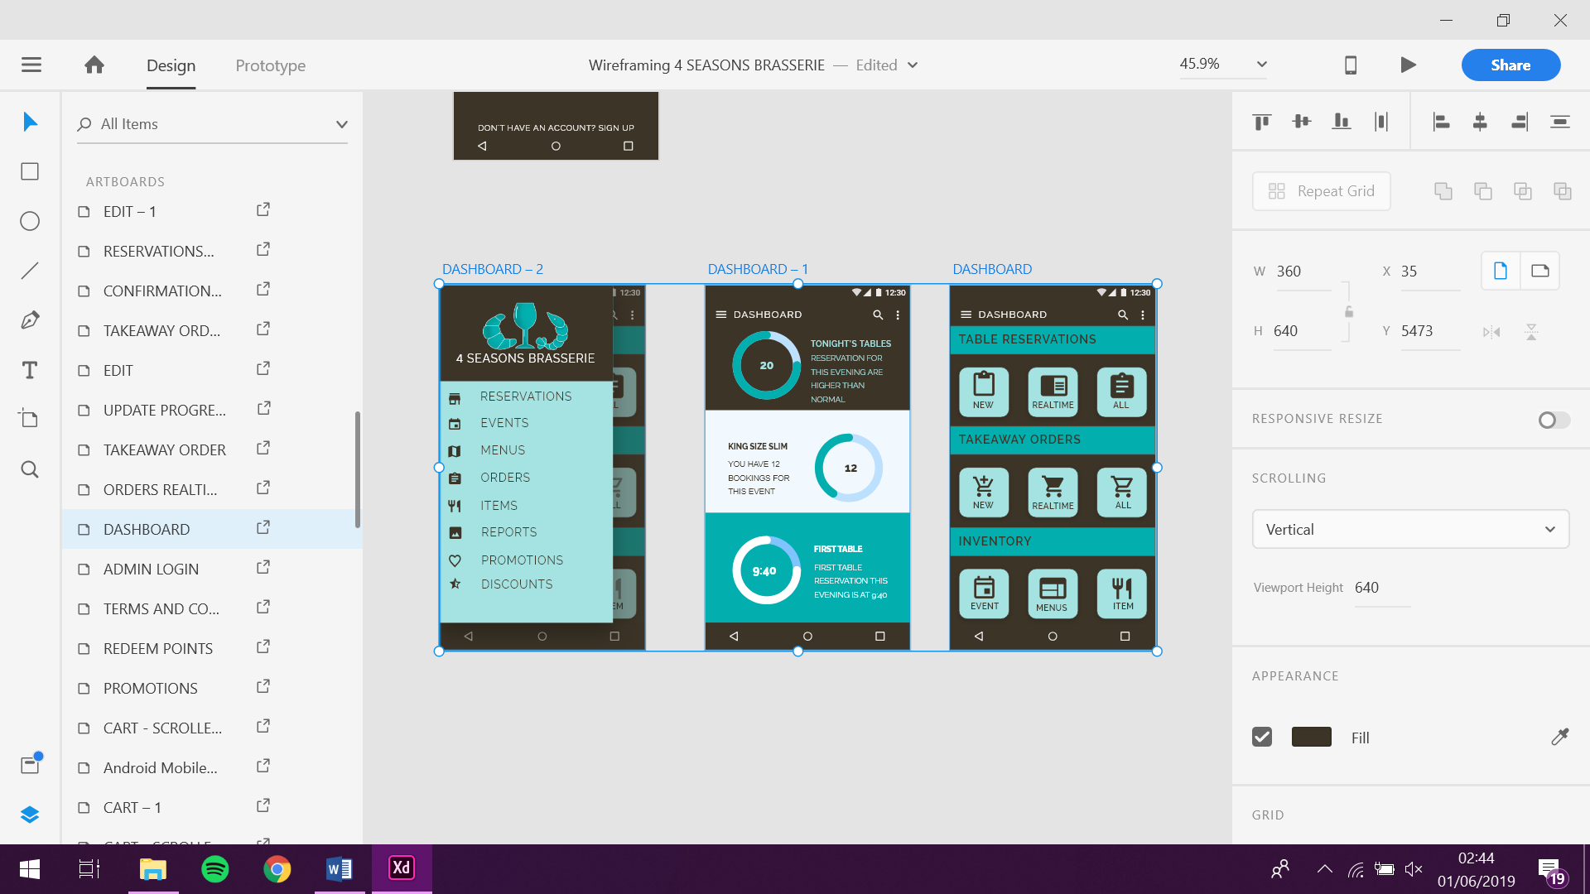

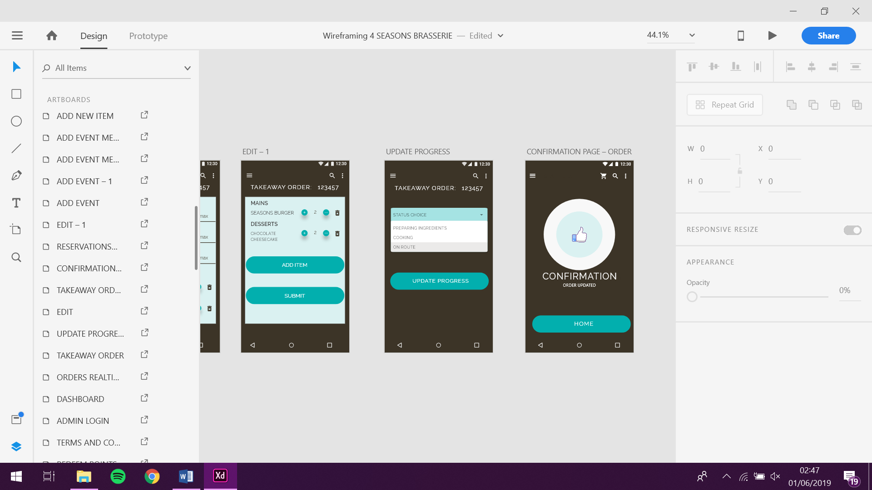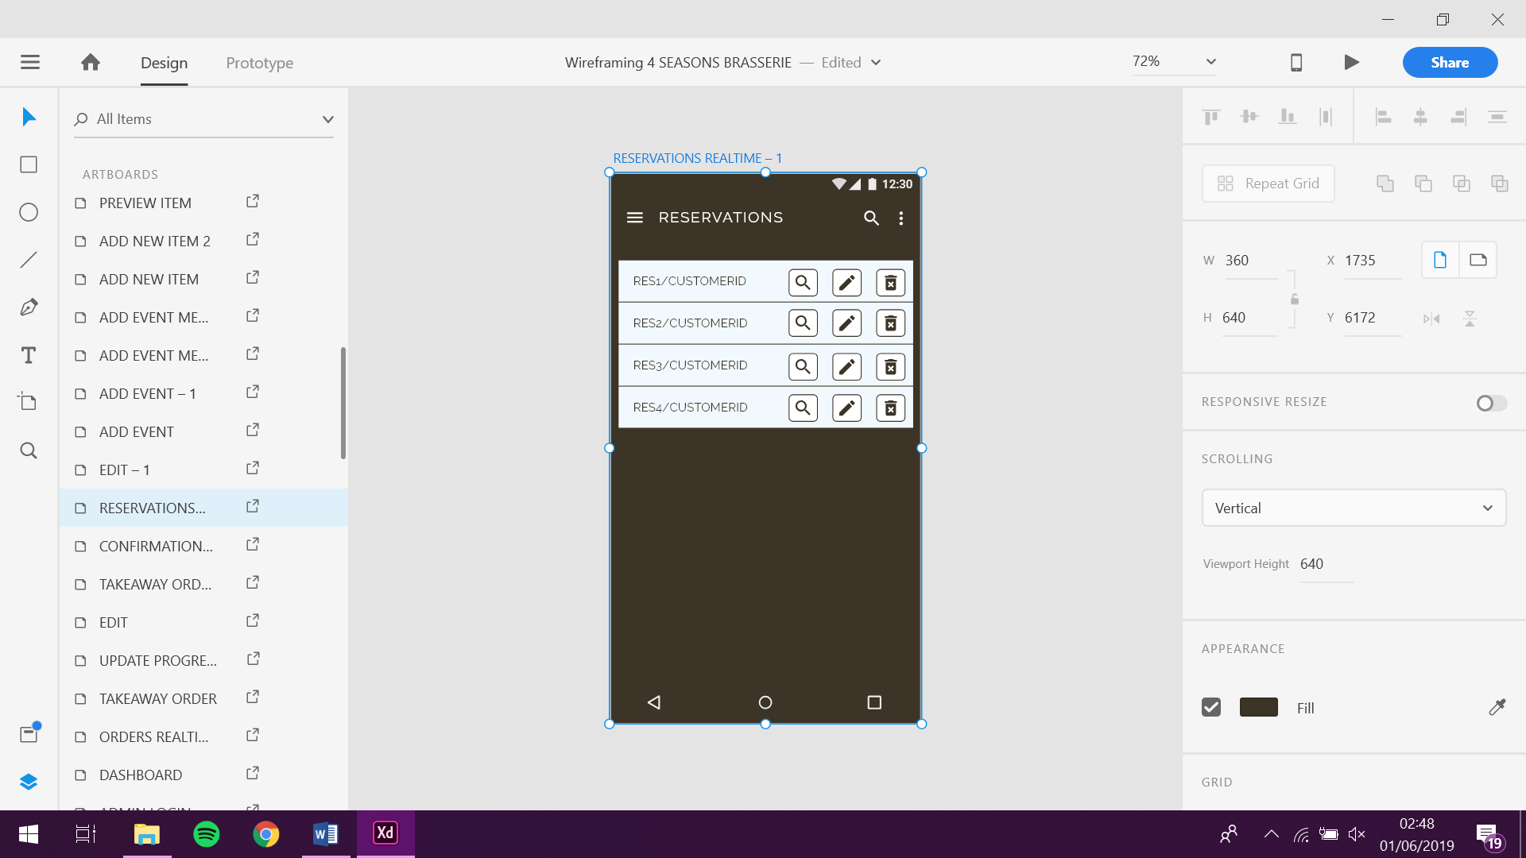

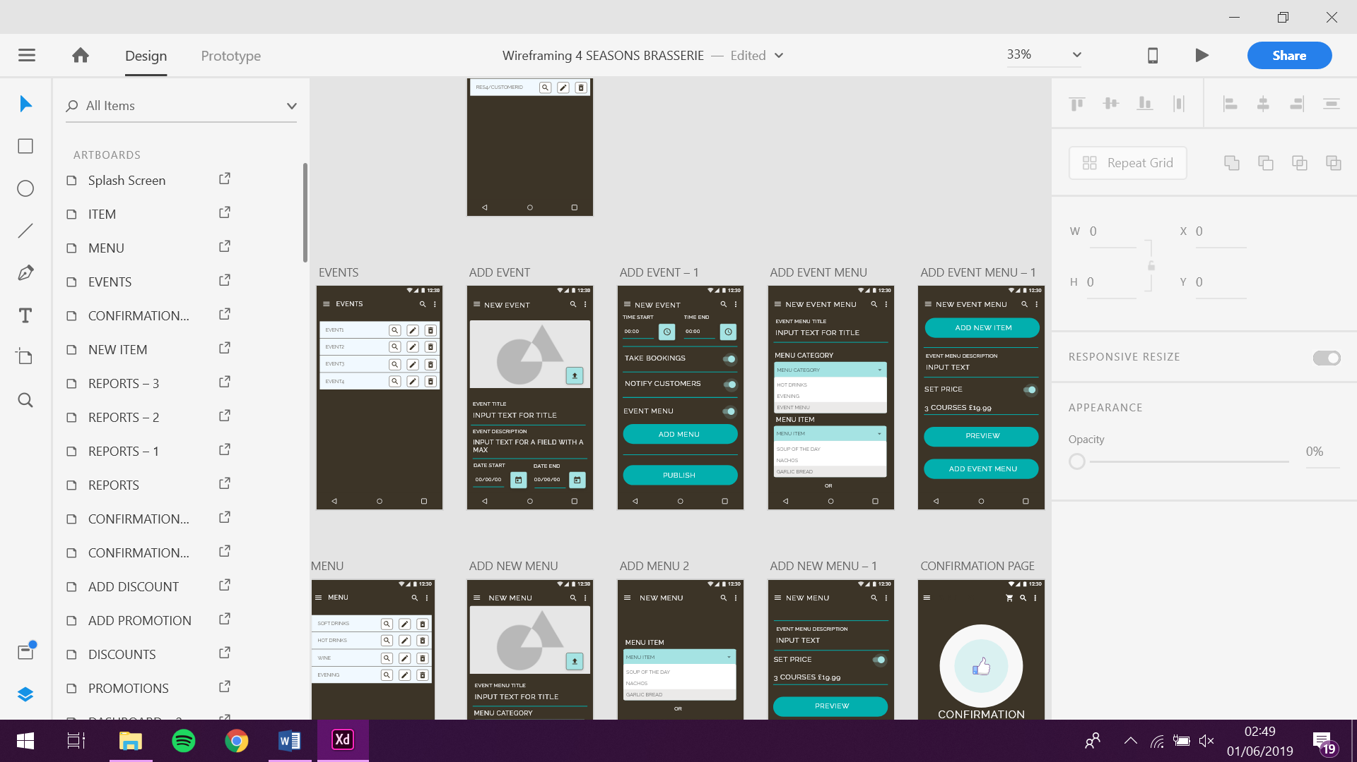

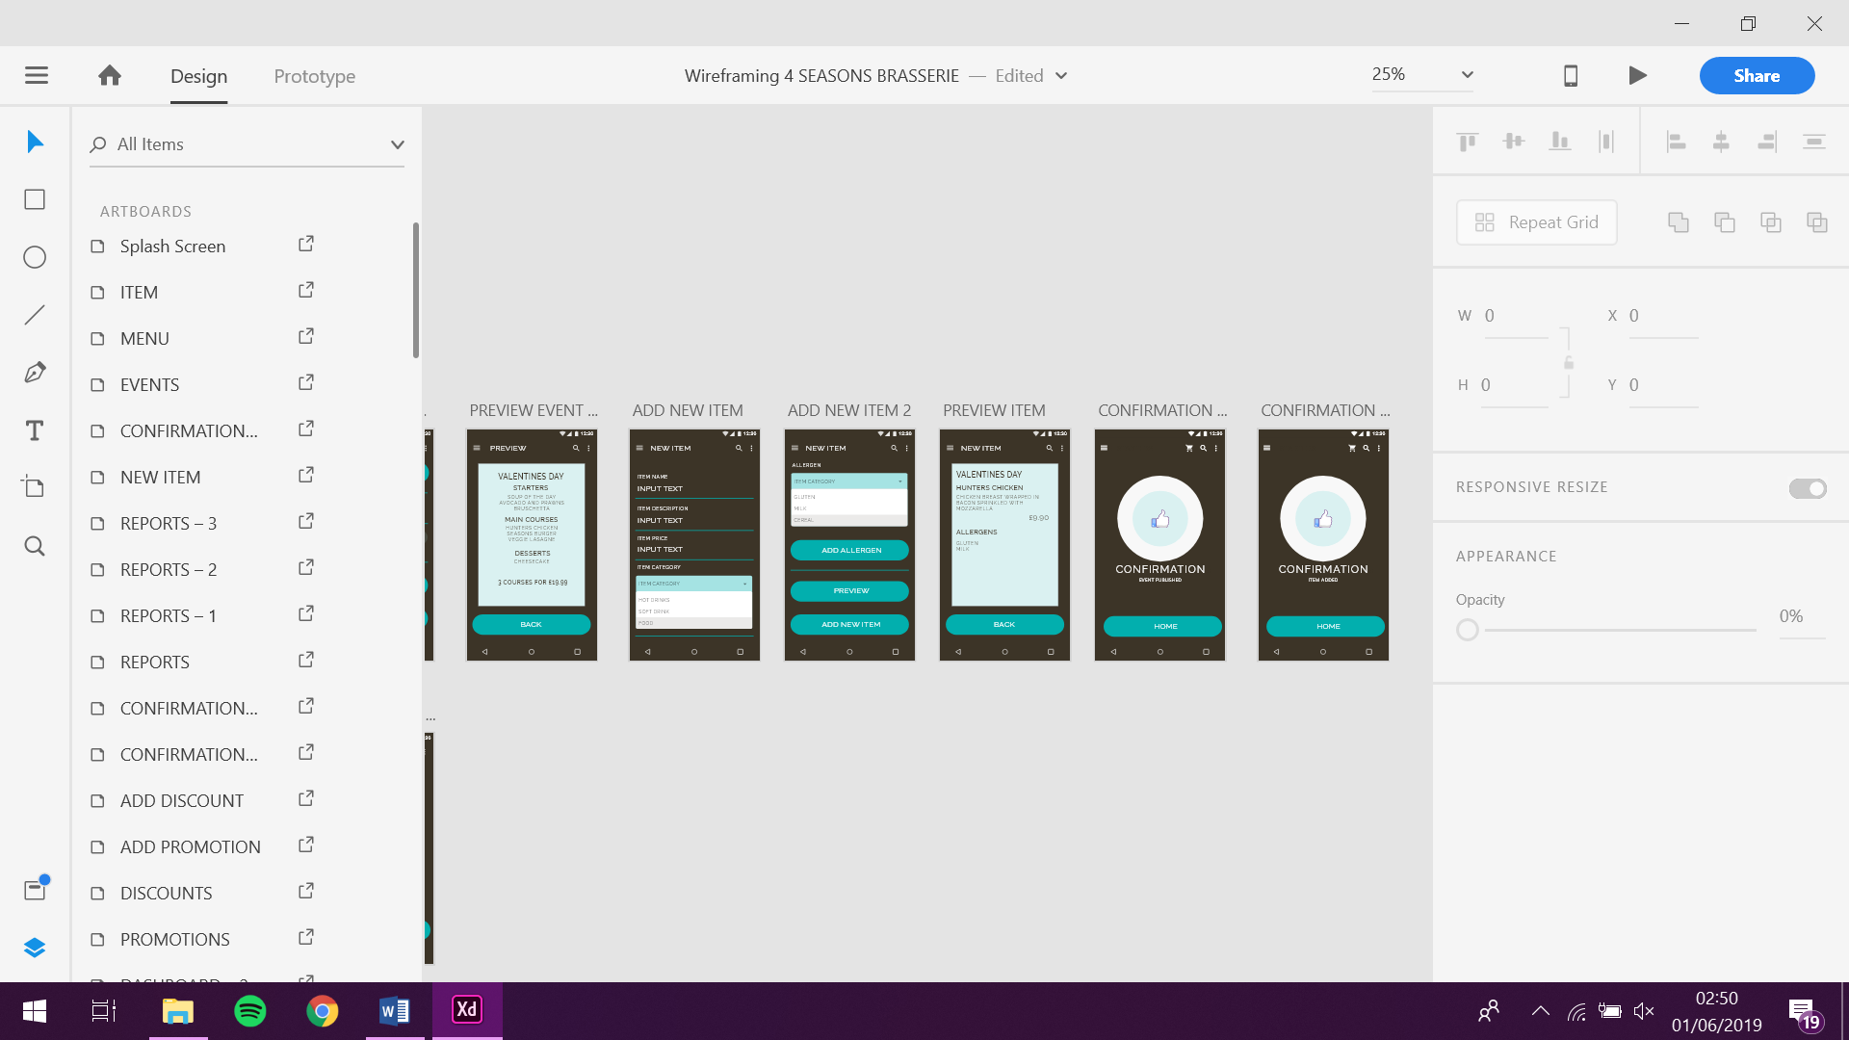

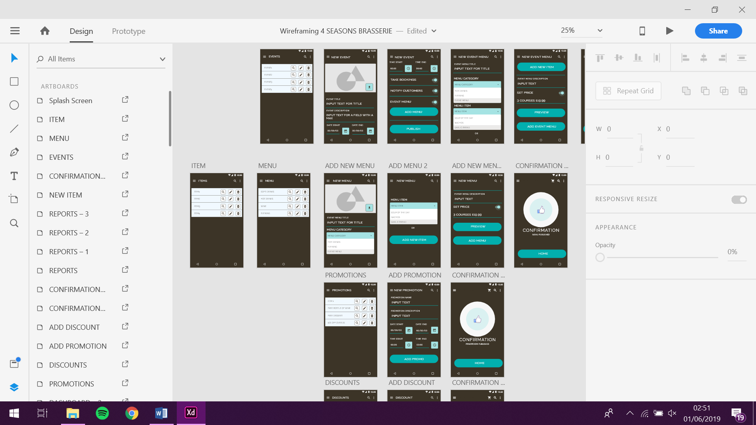

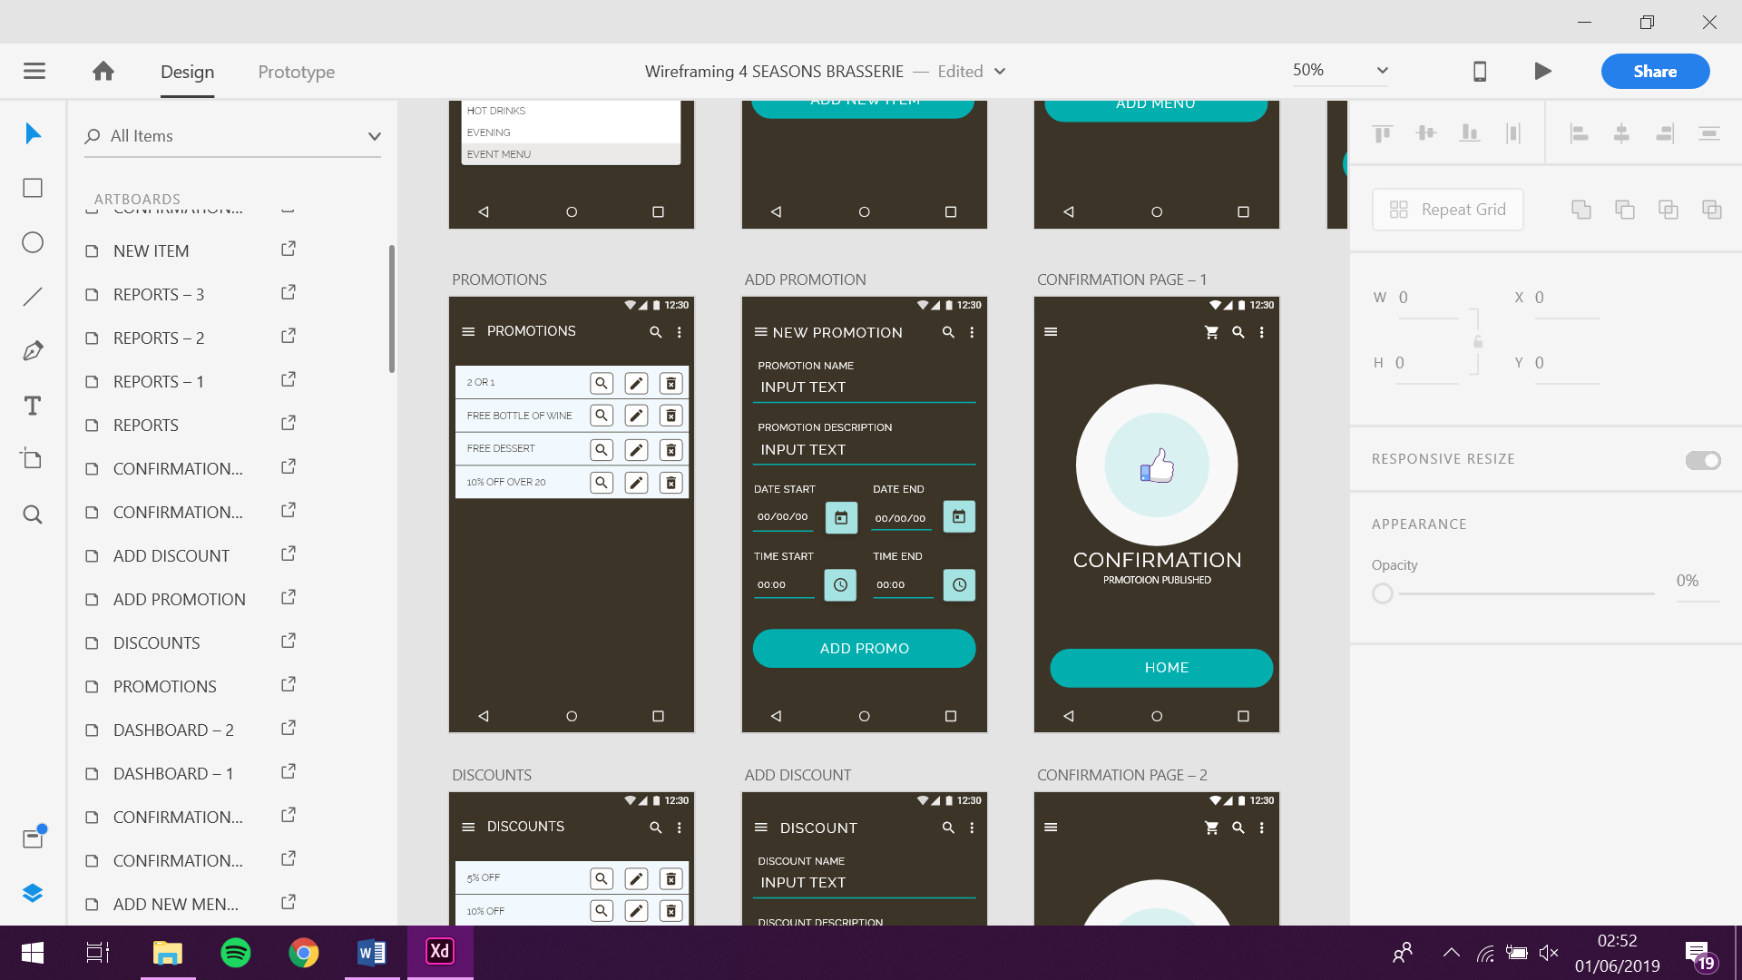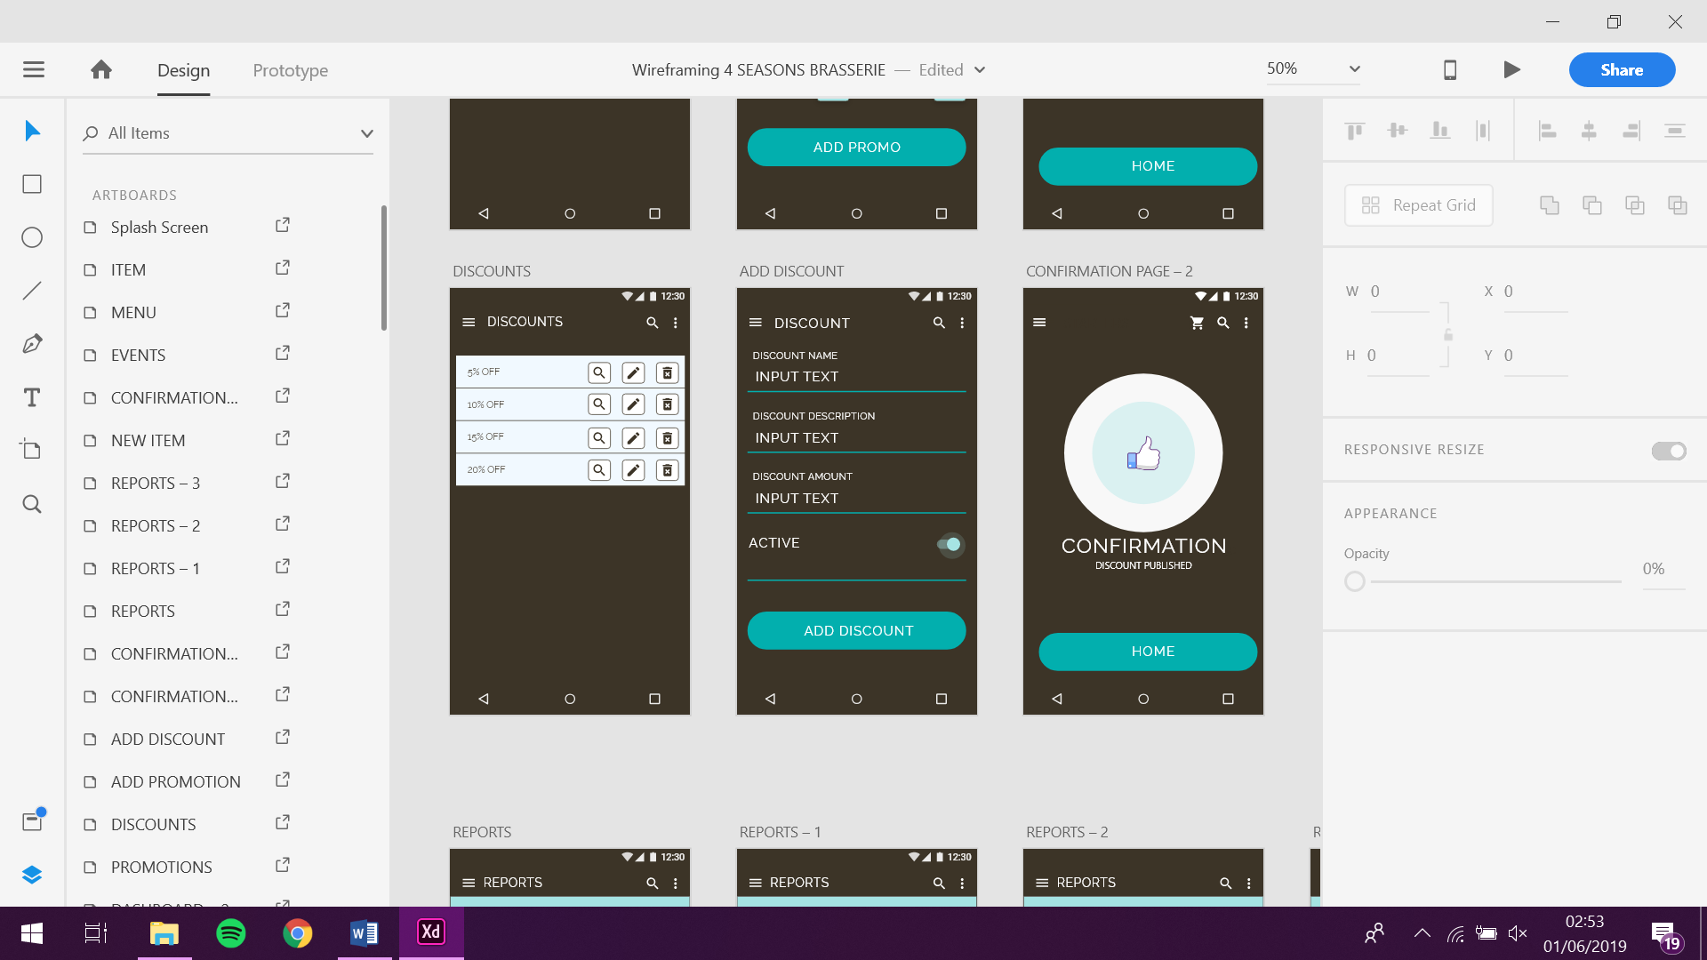

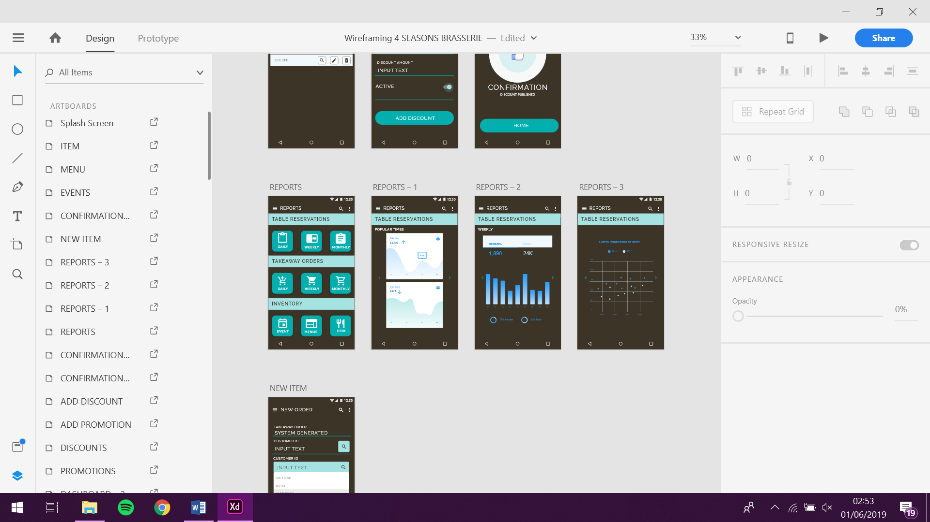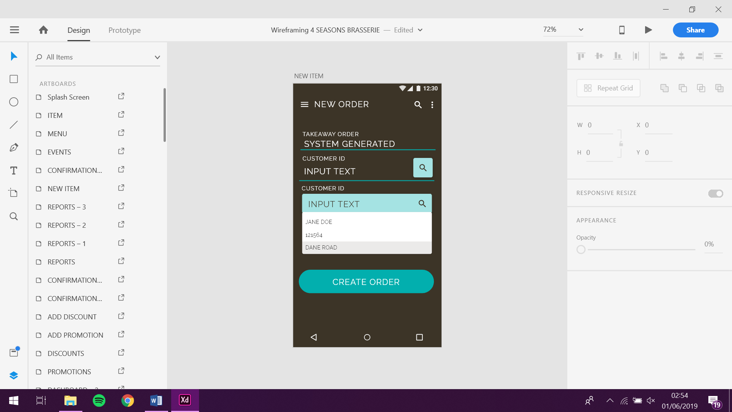

## 4.3 Wireflow

#### 4.3.1 Customer App Wireflow

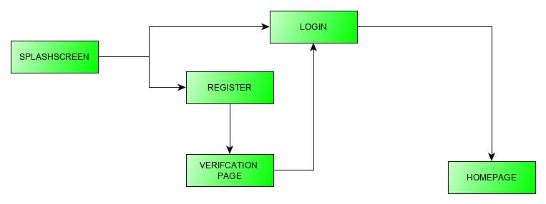

Figure 1 - Onboarding and login

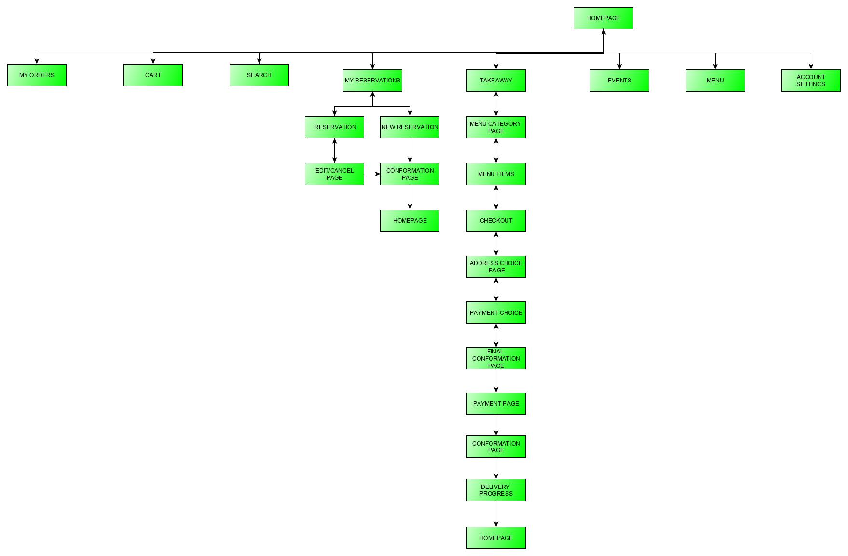

Figure 2 - App wire flow

#### 4.3.2. Admin Wireflow

Figure 6 - Event Wireflow

Figure 3 - Admin wire flow login and top-level pages

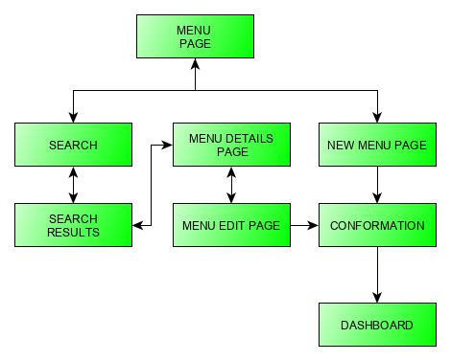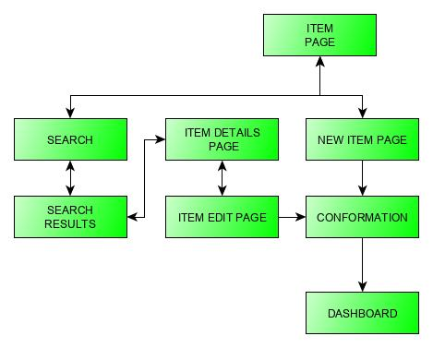

Figure 4 - Item Page Wire flow

Figure 5 - Menu Wire flow

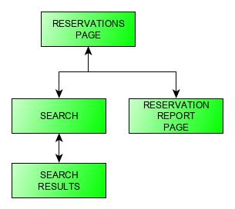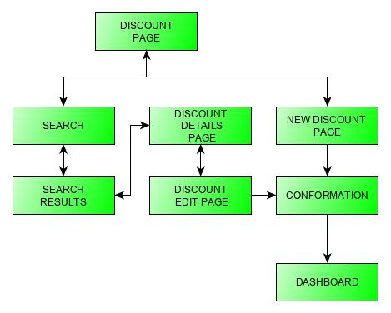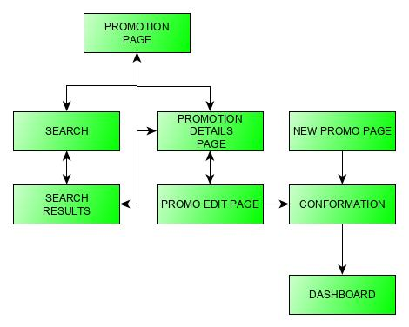

Figure 9 - Reservation Wire flow

Figure 8 - Discount Wire flow

Figure 7 - Promotion Wire flow

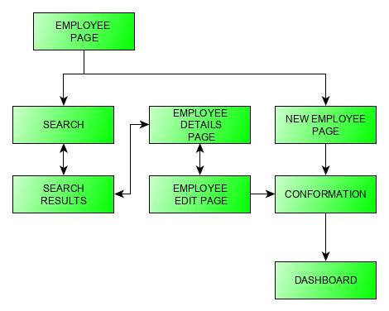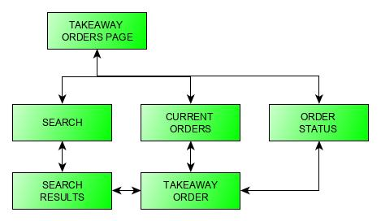

Figure 11 - Employee Wireflow

Figure 10 - Takeaway Orders Wireflow

# 5. Code Snippets

#### 5.1 Creation query code for database with no foreign keys

/*Tables with primary key only*/  
  
CREATE TABLE system_admin (  
 **system_admin_id** TINYINT(3) NOT NULL PRIMARY KEY,  
 **first_name** VARCHAR(20) NOT NULL,  
 **last_name** VARCHAR(20) NOT NULL,  
 **username** VARCHAR(20) NOT NULL,  
 **password** VARCHAR(20) NOT NULL,  
 **timestamp** TIMESTAMP NOT NULL);  
  
CREATE TABLE event_category (  
 **event_category** VARCHAR(150) NOT NULL PRIMARY KEY,  
 **category_description** VARCHAR(500));  
  
CREATE TABLE customer (  
 **customer_id** TINYINT(3) NOT NULL PRIMARY KEY,  
 **first_name** VARCHAR(20) NOT NULL,  
 **last_name** VARCHAR(20) NOT NULL,  
 **d_o_b** DATE NOT NULL,  
 **email** VARCHAR(50) NOT NULL,  
 **password** VARCHAR(20) NOT NULL,  
 **timestamp** TIMESTAMP NOT NULL);

#### 5.2 Creation query code with alter table statement (from MYISAM to InnoDB)

/* SQL command to change tables into INNODB tables for foreign key constraints */  
  
ALTER TABLE system_admin ENGINE=InnoDB;  
ALTER TABLE event_category ENGINE=InnoDB;  
ALTER TABLE customer ENGINE=InnoDB;  
ALTER TABLE reward_points ENGINE=InnoDB;  
ALTER TABLE table_no ENGINE=InnoDB;  
ALTER TABLE discount ENGINE=InnoDB;  
ALTER TABLE order_status ENGINE=InnoDB;  
ALTER TABLE payment_method ENGINE=InnoDB;  
ALTER TABLE measure ENGINE=InnoDB;  
ALTER TABLE country ENGINE=InnoDB;  
ALTER TABLE tasting_guide ENGINE=InnoDB;  
ALTER TABLE allergen ENGINE=InnoDB;  
ALTER TABLE item ENGINE=InnoDB;  
ALTER TABLE drink_category ENGINE=InnoDB;

#### 5.3 Creation query code with foreign key references

/*Tables with foreign key references*/  
  
CREATE TABLE employee (  
 **employee_id** TINYINT(3) NOT NULL PRIMARY KEY,  
 **first_name** VARCHAR(20) NOT NULL,  
 **last_name** VARCHAR(20) NOT NULL,  
 **username** VARCHAR(20) NOT NULL,  
 **password** VARCHAR(20) NOT NULL,  
 **timestamp** TIMESTAMP NOT NULL,  
 **system_admin_id** TINYINT(3) NOT NULL,  
 FOREIGN KEY(**system_admin_id**) REFERENCES system_admin(**system_admin_id**));  
  
CREATE TABLE promo (  
 **promo_id** TINYINT(5) NOT NULL PRIMARY KEY,  
 **promo_name** VARCHAR(250) NOT NULL,  
 **promo_description** VARCHAR(1000) NOT NULL,  
 **promo_start_date** DATETIME NOT NULL,  
 **promo_end_date** DATETIME NOT NULL,  
 **promo_cover_image** BLOB NULL,  
 **promo_terms** VARCHAR(2000) NOT NULL,  
 **timestamp** TIMESTAMP NOT NULL,  
 **system_admin_id** TINYINT(3) NOT NULL,  
 FOREIGN KEY(**system_admin_id**) REFERENCES system_admin(**system_admin_id**));  
  
CREATE TABLE event (  
 **event_id** TINYINT(5) NOT NULL PRIMARY KEY,  
 **event_name** VARCHAR(150) NOT NULL,  
 **event_date** DATETIME NOT NULL,  
 **event_text** VARCHAR(1000),  
 **event_cover_image** BLOB NULL,  
 **timestamp** TIMESTAMP NOT NULL,  
 **system_admin_id** TINYINT(3) NOT NULL,  
 **event_category** VARCHAR(150) NOT NULL,  
 FOREIGN KEY(**system_admin_id**) REFERENCES system_admin(**system_admin_id**),  
 FOREIGN KEY(**event_category**) REFERENCES event_category(**event_category**));  
  
CREATE TABLE menu (  
 **menu_id** TINYINT(3) NOT NULL PRIMARY KEY,  
 **menu_name** VARCHAR(150) NOT NULL,  
 **menu_description** VARCHAR(1000) NOT NULL,  
 **timestamp** TIMESTAMP NOT NULL,  
 **system_admin_id** TINYINT(3) NOT NULL,  
 FOREIGN KEY(**system_admin_id**) REFERENCES system_admin(**system_admin_id**));  
  
CREATE TABLE event_menu (  
 **menu_id** TINYINT(5) NOT NULL,  
 **event_id** TINYINT(5) NOT NULL,  
 FOREIGN KEY(**menu_id**) REFERENCES menu(**menu_id**),  
 FOREIGN KEY(**event_id**) REFERENCES event(**event_id**));  
  
CREATE TABLE customer_delivery_address (  
 **customer_delivery_address_id** TINYINT(3) NOT NULL PRIMARY KEY,  
 **delivery_address_1** VARCHAR(250) NOT NULL,  
 **delivery_address_2** VARCHAR(250) NOT NULL,  
 **postcode** VARCHAR(8) NOT NULL,  
 **country_id** TINYINT(3) NOT NULL,  
 **customer_id** TINYINT(3) NOT NULL,  
 FOREIGN KEY(**country_id**) REFERENCES country(**country_id**),  
 FOREIGN KEY(**customer_id**) REFERENCES customer(**customer_id**));  
  
CREATE TABLE customer_reward_points (  
 **reward_point_id** TINYINT(5) NOT NULL,  
 **customer_id** TINYINT(3) NOT NULL,  
 **reward_points** TINYINT(3) NOT NULL,  
 FOREIGN KEY(**reward_point_id**) REFERENCES reward_points(**reward_point_id**),  
 FOREIGN KEY(**customer_id**) REFERENCES customer(**customer_id**));

#### 5.4 Insert Query Code

/* Insert testing data into table */  
  
/* Insert testing data into system admin table */  
  
INSERT INTO system_admin (system_admin_id, first_name, last_name, username, password, timestamp)  
VALUES ('1', 'amy', 'fal', 'admin', 'admin123', '2019-05-27');  
INSERT INTO system_admin (system_admin_id, first_name, last_name, username, password, timestamp)  
VALUES ('2', 'bob', 'fal', 'bobfal', 'bob123', '2019-05-27');  
  
/* Insert testing data into event category table */  
  
INSERT INTO event_category (event_category, category_description)  
VALUES ('Live Music', 'A mixture of live music from acoustic to jazz');  
INSERT INTO event_category (event_category, category_description)  
VALUES ('Mrs Yarringtons Live Music Tour', 'A mixture of live music from acoustic to jazz');  
INSERT INTO event_category (event_category, category_description)  
VALUES ('Fine dining', 'An evening of exquisite food and dining experience');  
INSERT INTO event_category (event_category, category_description)  
VALUES ('Mothers Day', '12th March, Celebrate with us');  
INSERT INTO event_category (event_category, category_description)  
VALUES ('Christmas', 'Christmas Season, December');  
  
/* Insert testing data into customer table */  
  
INSERT INTO customer (customer_id, first_name, last_name, d_o_b, email, password, timestamp)  
VALUES ('12','jane','doe','1991-04-04','jane@hotmail.com','12345','2019-05-27');  
INSERT INTO customer (customer_id, first_name, last_name, d_o_b, email, password, timestamp)  
VALUES ('1','aaron','clarke','1991-02-02','nesta@google.com','nesta123','2019-05-27');  
INSERT INTO customer (customer_id, first_name, last_name, d_o_b, email, password, timestamp)  
VALUES ('3','nikki','sen','1994-04-05','nikki12@yahoo.com','12345','2019-05-27');  
INSERT INTO customer (customer_id, first_name, last_name, d_o_b, email, password, timestamp)  
VALUES ('4','jake','penfold','1989-01-04','jakey4@gmail.com','jake1','2019-05-27');  
INSERT INTO customer (customer_id, first_name, last_name, d_o_b, email, password, timestamp)  
VALUES ('2','laila','garrattay','1989-01-01','laila@yahoo.com','laila123','2019-05-27');  
  
/* Insert testing data into reward points table */  
  
INSERT INTO reward_points (reward_point_id, reward_point_name, reward_point_amount)  
VALUES ('1', '1 Reward Point', '1');  
INSERT INTO reward_points (reward_point_id, reward_point_name, reward_point_amount)  
VALUES ('2', '2 Reward Points', '2');  
INSERT INTO reward_points (reward_point_id, reward_point_name, reward_point_amount)  
VALUES ('3', '5 Reward Points', '5');

#### 5.5 Android Application Java Code

package com.example.a4sb;  
  
import android.content.Intent;  
import android.support.v7.app.AppCompatActivity;  
import android.os.Bundle;  
import android.view.View;  
  
public class MainActivity extends AppCompatActivity {  
  
 @Override  
 protected void onCreate(Bundle savedInstanceState) {  
 super.onCreate(savedInstanceState);  
 setContentView(R.layout.*activity_main*);  
  
 }  
  
 public void register(View view) {  
 Intent intent = new Intent(getApplicationContext(),  
 RegisterActivity.class);  
 startActivity(intent);  
 finish();  
 }  
}

# 6. Testing

|  |  |  |  |  |  |  |  |
| --- | --- | --- | --- | --- | --- | --- | --- |
| **Test ID** | **Test Name** | **Test Type** | **Development iteration** | **Source** | **Expected** | **Result** | **Date** |
| 1 | Splash screen | Transition | Prototype | Splash screen | Transition to login | Successful | 10/06/2019 |
| 2 | Login Button | button click | Prototype | Login Page | to home page | Successful | 10/06/2019 |
| 3 | Sign Up Button | button click | Prototype | Login Page | to registration page | Successful | 10/06/2019 |
| 4 | Sign Up Button | button click | Prototype | Registration page 1 | to 2nd registration page | Successful | 10/06/2019 |
| 5 | Registration Button | button click | Prototype | Registration page 2 | to onboarding | Successful | 10/06/2019 |
| 6 | Next Button | button click | Prototype | Onboarding 1 | to onboarding 2 | Successful | 10/06/2019 |
| 7 | Next Button | button click | Prototype | Onboarding 2 | to onboarding 3 | Successful | 10/06/2019 |
| 8 | Prev Button | button click | Prototype | Onboarding 2 | to onboarding 1 | Successful | 10/06/2019 |
| 9 | Next Button | button click | Prototype | Onboarding 3 | to onboarding 4 | Successful | 10/06/2019 |
| 10 | Prev Button | button click | Prototype | Onboarding 3 | to onboarding 3 | Successful | 10/06/2019 |
| 11 | Next Button | button click | Prototype | Onboarding 4 | to home page | Successful | 10/06/2019 |
| 12 | Side Nav button | button click | Prototype | Home | slide out side nav | Successful | 10/06/2019 |
| 13 | Side Nav Arrow | button click | Prototype | Home | slide in side nav | Successful | 10/06/2019 |
| 14 | Top right icon | button click | Prototype | Home | fade in drop down | Successful | 10/06/2019 |
| 15 | Settings close icon | button click | Prototype | Home | fade out drop down | Successful | 10/06/2019 |
| 16 | search icon in the navbar | button click | Prototype | Home | on click fades in search bar | Successful | 10/06/2019 |
| 17 | View button | button click | Prototype | Home | to events page | Successful | 10/06/2019 |
| 18 | Redeem button | button click | Prototype | Home | to redeem page | Successful | 10/06/2019 |
| 19 | Order button | button click | Prototype | Home | to menu page | Successful | 10/06/2019 |
| 20 | Book button | button click | Prototype | Home | to reservations page | Successful | 10/06/2019 |
| 21 | Event button | button click | Prototype | Home | to events page | Successful | 10/06/2019 |
| 22 | Side Nav - My reservations button | button click | Prototype | Home - Side Nav | to my reservations page | Successful | 10/06/2019 |
| 23 | Side Nav - Book a table button | button click | Prototype | Home - Side Nav | to reservations page | Successful | 10/06/2019 |
| 24 | Side Nav - My Orders | button click | Prototype | Home - Side Nav | to my orders page | Successful | 10/06/2019 |
| 25 | Side Nav - Takeaway | button click | Prototype | Home - Side Nav | to menu page | Successful | 10/06/2019 |
| 26 | Side Nav - Events | button click | Prototype | Home - Side Nav | to events page | Successful | 10/06/2019 |
| 27 | Side Nav - Take a look | button click | Prototype | Home - Side Nav | NO ASSOCIATED ACTIVITY | Successful | 10/06/2019 |
| 28 | Side Nav - Promotions | button click | Prototype | Home - Side Nav | to promotions page | Successful | 10/06/2019 |
| 29 | Event scroll | Scroll | Prototype | Events | scroll event page | Successful | 10/06/2019 |
| 30 | Event card | button click | Prototype | Events | to individual event page | Successful | 10/06/2019 |
| 31 | Event card previous button | button click | Prototype | Individual Event | to events page | Successful | 10/06/2019 |
| 32 | Reserve a table button | button click | Prototype | Individual Event | to reservations page | Successful | 10/06/2019 |
| 33 | Menu scroll | Scroll | Prototype | Menu | scroll menu page | Successful | 10/06/2019 |
| 34 | Menu buttons | button click | Prototype | Menu | All but the evening menu result in dialogue box | Successful | 10/06/2019 |
| 35 | Evening menu button | button click | Prototype | Menu | to evening menu | Successful | 10/06/2019 |
| 36 | Starters button | button click | Prototype | Evening Menu | to starters | Successful | 10/06/2019 |
| 37 | all other menu buttons on the evening menu | button click | Prototype | Evening Menu | NO ASSOCIATED ACTIVITY | Successful | 10/06/2019 |
| 38 | soup of the day dropdown | button click | Prototype | Evening Menu | drop down description | Successful | 10/06/2019 |
| 39 | allergy buttons | button click | Prototype | Evening Menu | to allergy page | Successful | 10/06/2019 |
| 40 | back to menu button | button click | Prototype | Allergens | to menu page | Successful | 10/06/2019 |
| 41 | add to cart button | button click | Prototype | Evening Menu | to dialogue box | Successful | 10/06/2019 |
| 42 | checkout button | button click | Prototype | Evening Menu dialogue box | Special request page | Successful | 10/06/2019 |
| 43 | continue button | button click | Prototype | Special request page | delivery or collection page | Successful | 10/06/2019 |
| 44 | delivery button | button click | Prototype | delivery or collection page | to choose time drop down | Successful | 10/06/2019 |
| 45 | time drop down | button click | Prototype | time page | to address page | Successful | 10/06/2019 |
| 46 | collection button | button click | Prototype | time page | to address page | Successful | 10/06/2019 |
| 47 | previous delivery address drop down | drop down | Prototype | address page | to drop down page | Successful | 10/06/2019 |
| 48 | new address button | button click | Prototype | address page | to new address page | Successful | 10/06/2019 |
| 49 | checkout button | button click | Prototype | address page | to checkout page | Successful | 10/06/2019 |
| 50 | payment button | button click | Prototype | checkout page | to payment page | Successful | 10/06/2019 |
| 51 | pay button | button click | Prototype | payment page | to confirmation page | Successful | 10/06/2019 |
| 52 | track progress button | button click | Prototype | confirmation page | to track progress page | Successful | 10/06/2019 |
| 53 | Prev and Next buttons | button click | Prototype | track progress | to and back through the track progress pages | Successful | 10/06/2019 |
| 54 | admin splashscreen | gesture | Prototype | Splashscreen | to login page | Successful | 10/06/2019 |
| 55 | Login Button | button click | Prototype | Login Page | to dashboard | Successful | 10/06/2019 |
| 56 | dashboard swipe | gesture | Prototype | Dashboard | to quick access toolbar | Successful | 10/06/2019 |
| 57 | navigation side menu button | button click | Prototype | Dashboard | slide out side nav | Successful | 10/06/2019 |
| 58 | new button | button click | Prototype | Dashboard | to new item page | Successful | 10/06/2019 |
| 59 | previous button | button click | Prototype | New item | to dashboard | Successful | 10/06/2019 |
| 60 | scroll down new item | gesture | Prototype | New item | Scroll down dashboard | Successful | 10/06/2019 |
| 61 | preview button | button click | Prototype | New item | to preview page | Successful | 10/06/2019 |
| 62 | back button | button click | Prototype | Preview page | back to new item page | Successful | 10/06/2019 |
| 63 | add new item | button click | Prototype | New item | to confirmation page | Successful | 10/06/2019 |
| 64 | home button | button click | Prototype | confirmation page | to home page | Successful | 10/06/2019 |
| 65 | realtime button | button click | Prototype | Dashboard | to reservations page | Successful | 10/06/2019 |
| 66 | all reservation button | button click | Prototype | Dashboard | to reservations page | Successful | 10/06/2019 |